 | BAHRIA UNIVERSITY, (Karachi Campus)  Department of Software Engineering  Assignment 3 - Spring 2025

COURSE TITLE: DevOps COURSE CODE: SEN-429
Class: BSE-8 B Shift: Morning
Course Instructor: Sohaib Ur Rehman Time Allowed: 1 Week
Submission Date: 18th May 2025 Max. Marks: 5 Marks

Name: Muhammad Shoaib Akhter Qadri Enrollment No: 02-131212-009

Solution:
Here is the step by step guideline:

- Create VPC First and keep nginx-vpc name and give IPv4 as 10.0.0.0/16

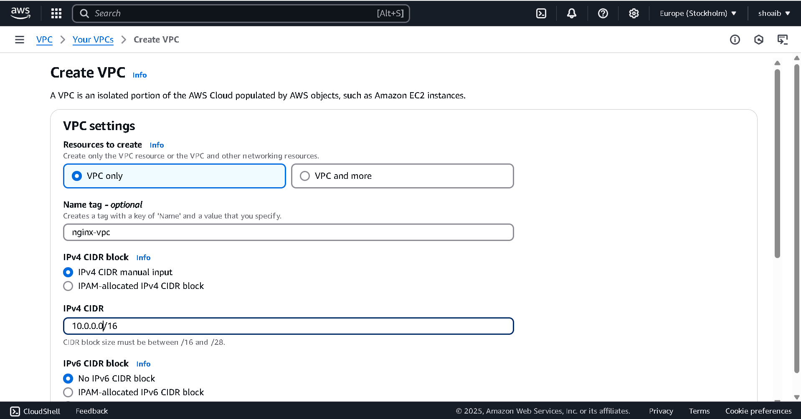

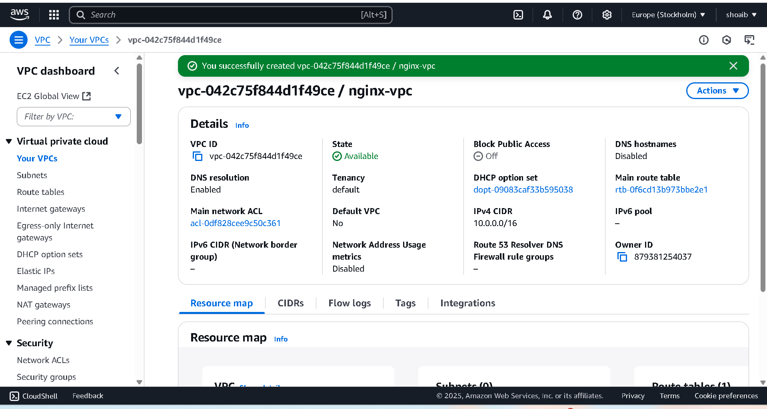

- Create 2 Subnets under above VPC.

Select nginx-vpc VPC and
give subnet name as my-subnet-1 and
select availability as eu-north-1a and
select IPv4 subnet CIDR block as 10.0.1.0/24

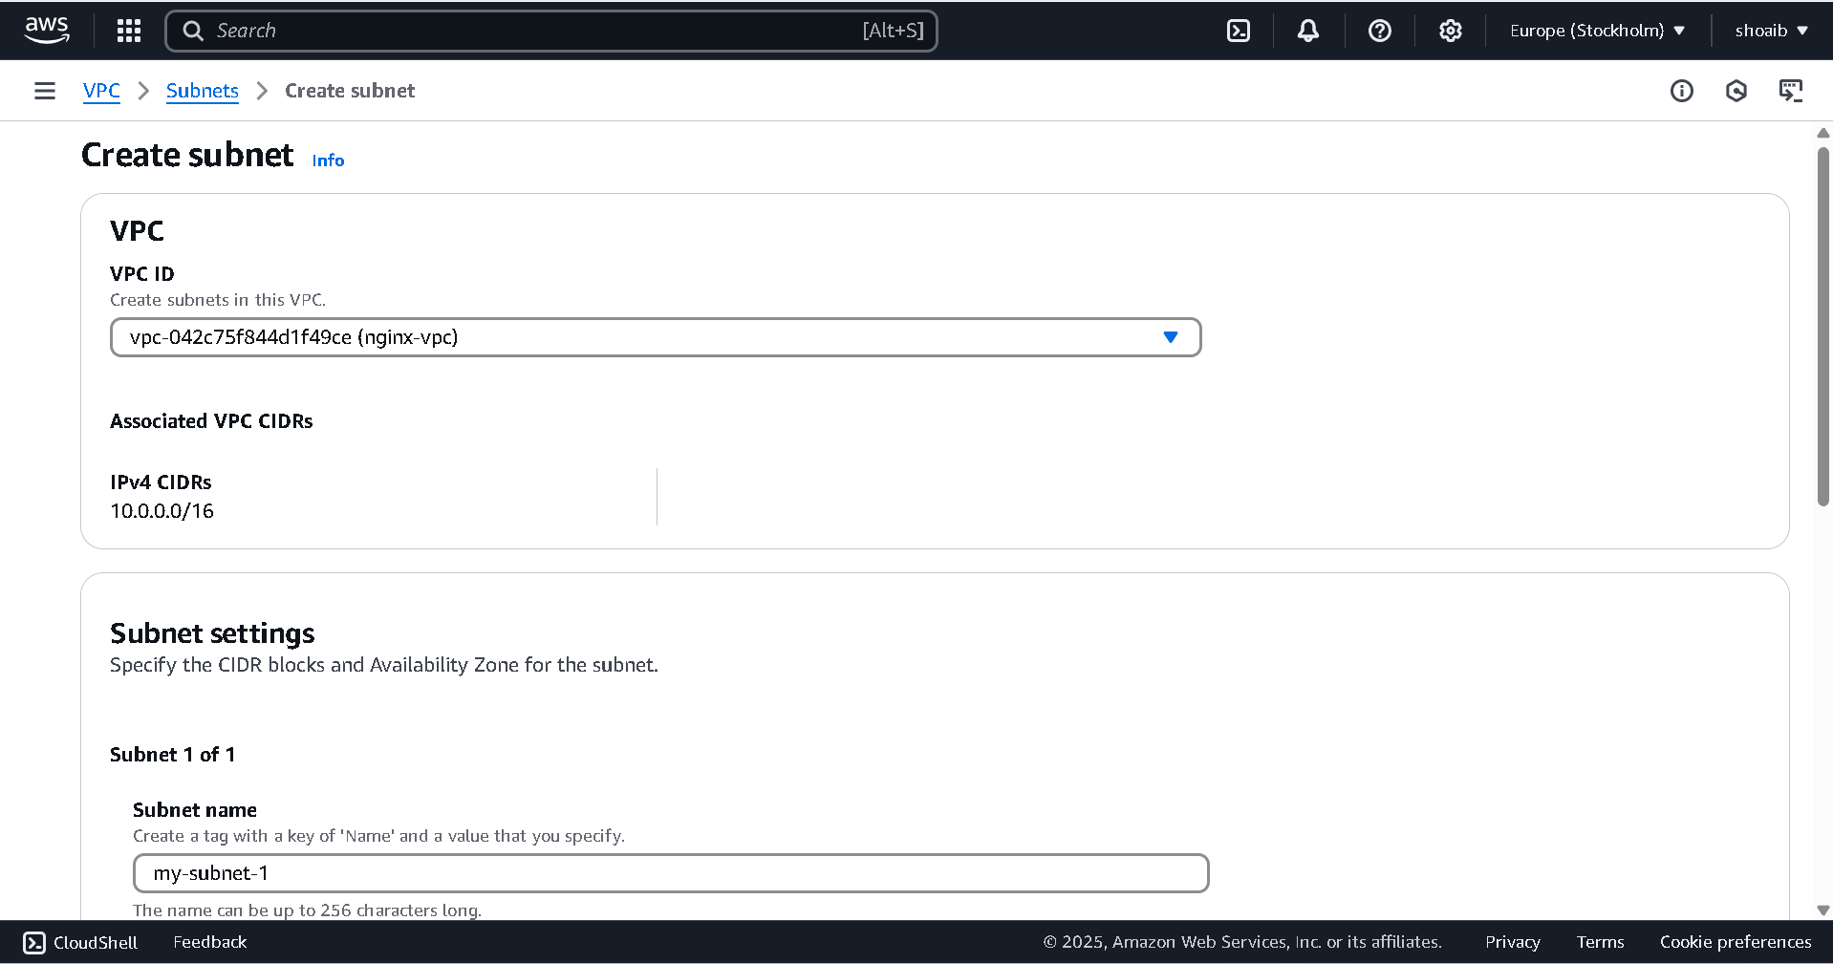

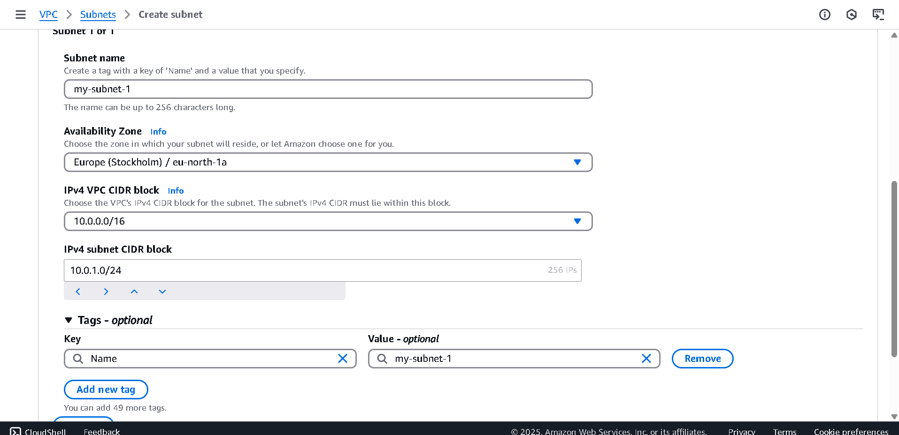

- Now created First subnet, then create second subnet

Select nginx-vpc VPC and
give subnet name as my-subnet-2 and
select availability as eu-north-1b and
select IPv4 subnet CIDR block as 10.0.2.0/24

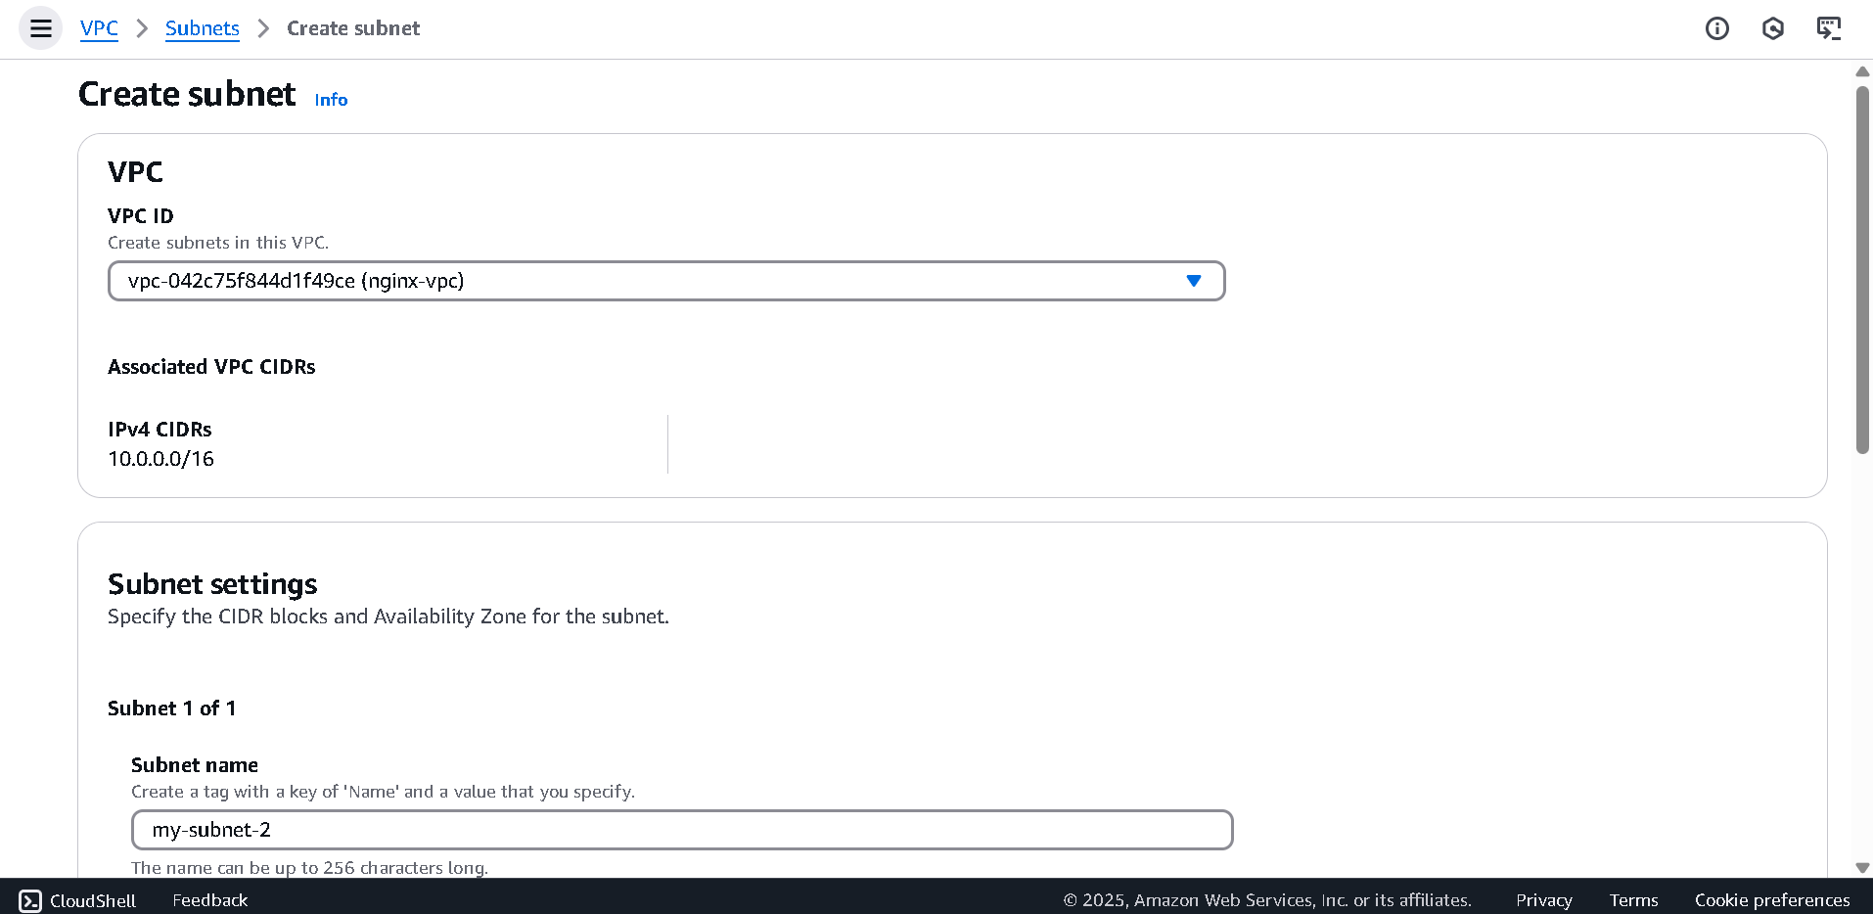

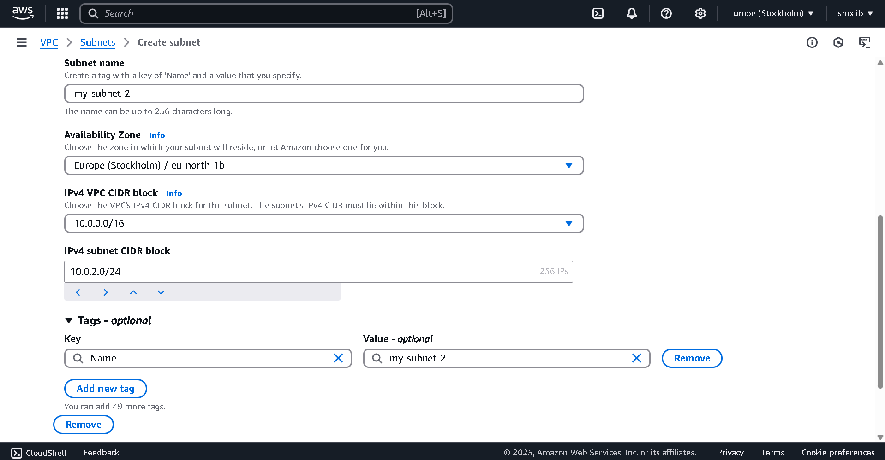

- Attached Internet Gateway also and keep name as nginx-igw

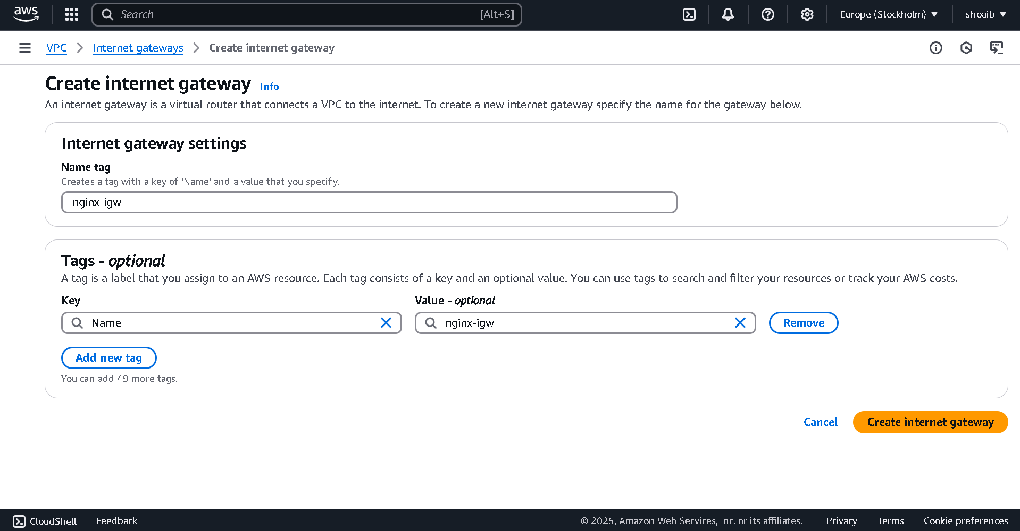

Select Internet Gateway and attached with VPC
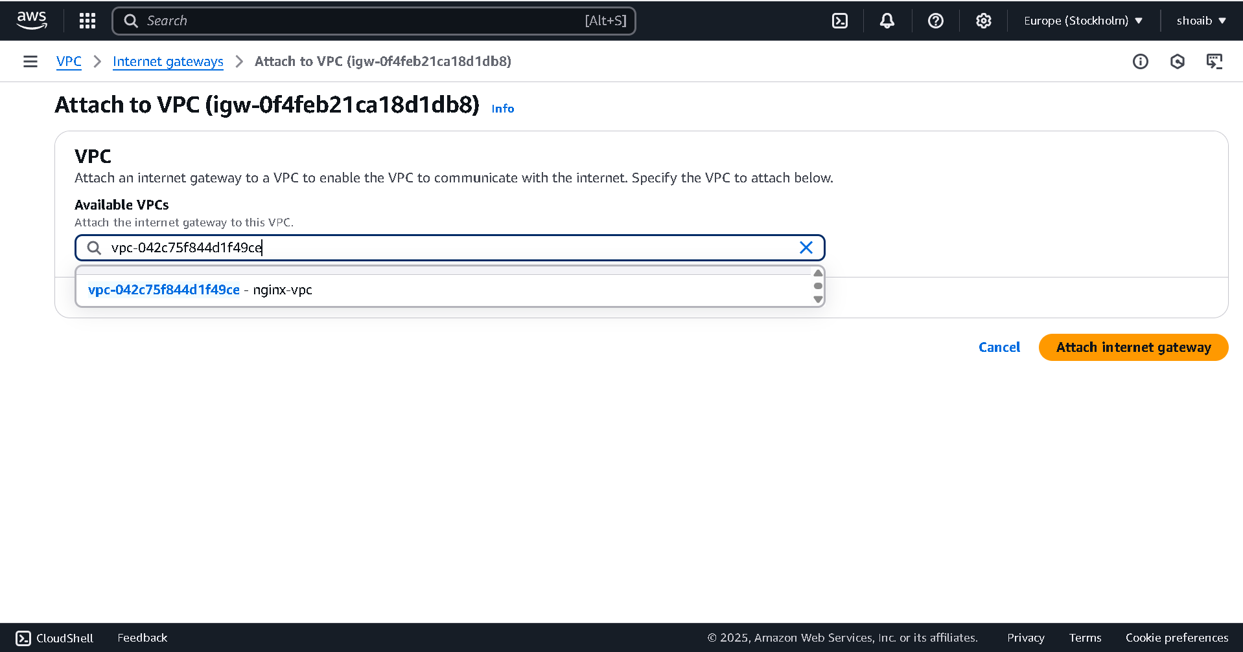

- Now create route table

Keep name nginx-RT and select your VPC also

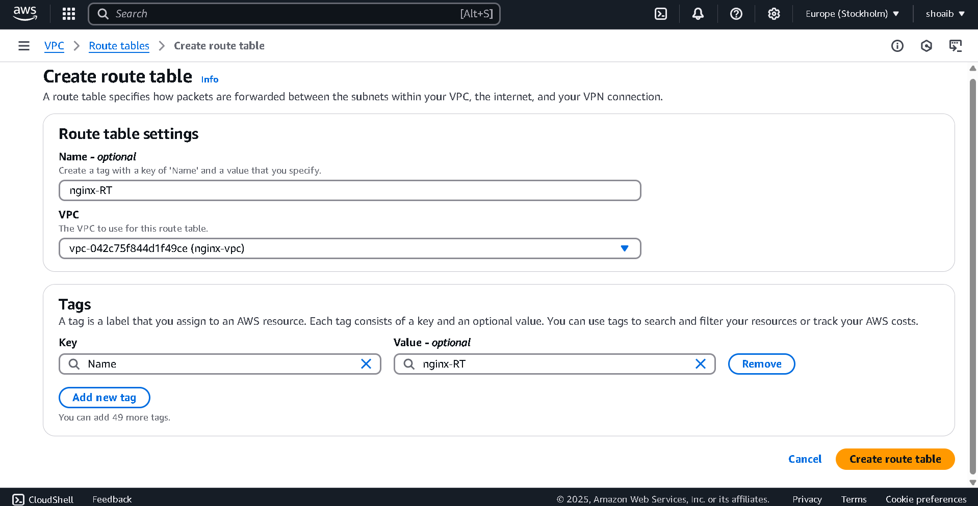

Now click edit routes and add route
And add 0.0.0.0/0 and select your internet gateway

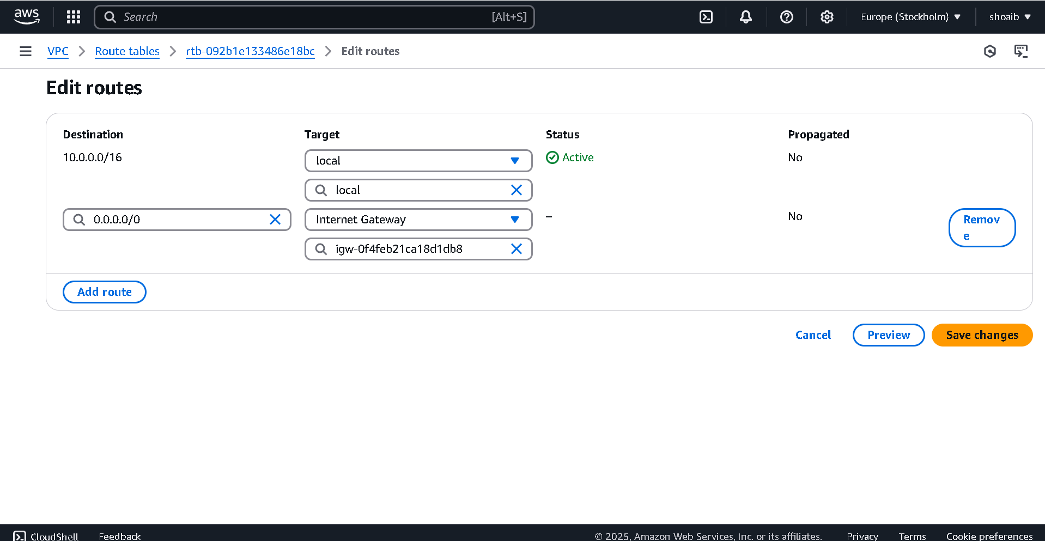

Now go to Subnet Associations Tab and click edit Subnet Associations and select 2 subnets

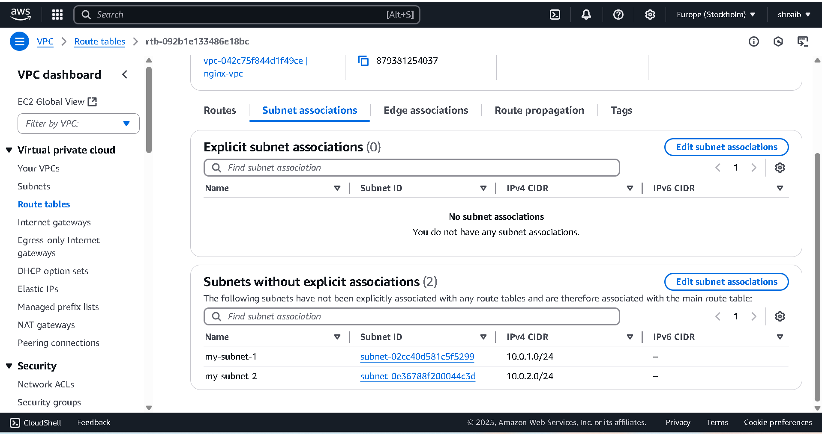

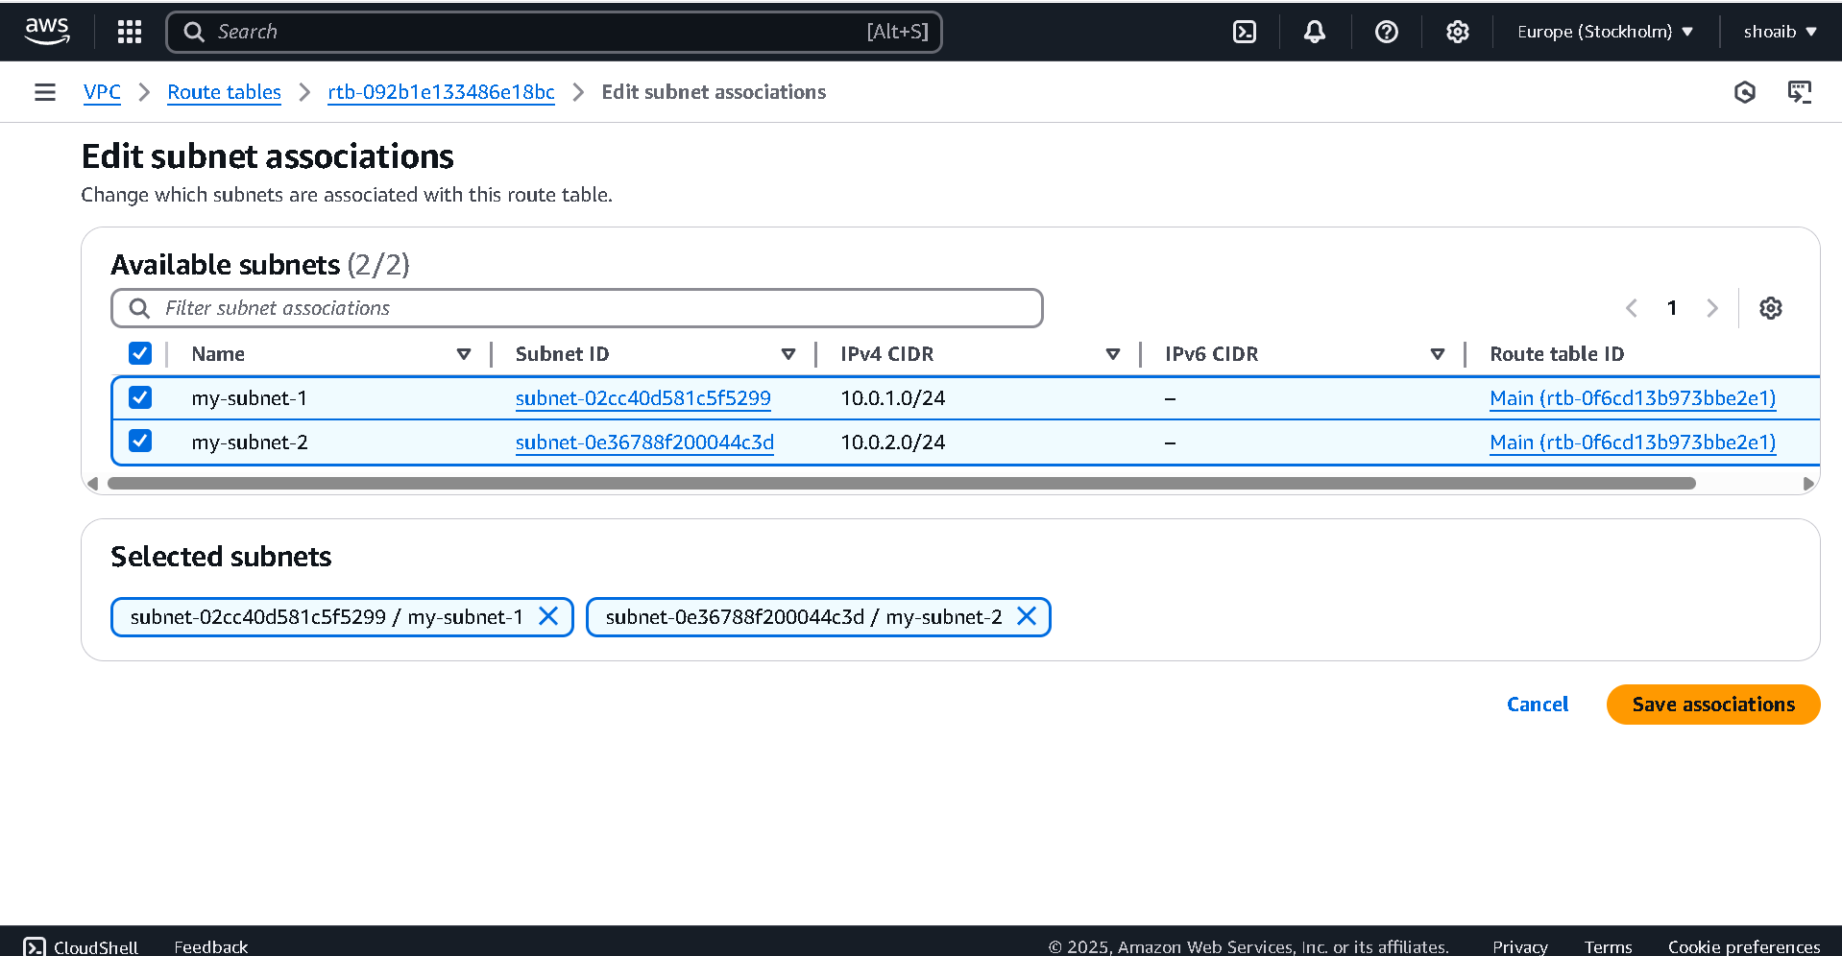

- Go to Security Group and keep name nginx-SG and add description like allow Firewall Traffic and select your VPC and add rule in Inbound Rule like
Type=HTTP
PORT=80
SOURCE=anywhere
And add one more rule like
Type=Custom TCP Port
Port range=8080
Source=anywhere

Add one more rule like

Type=All Traffic
Port range=all
Sourse=anywhere

Now click Create Security Group button

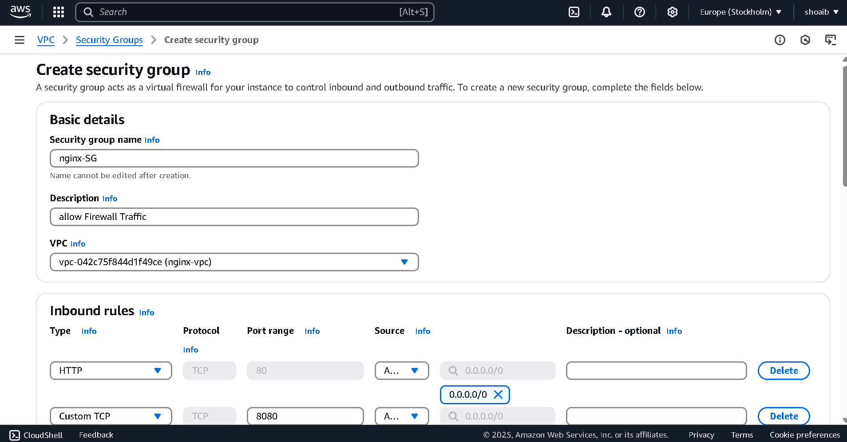

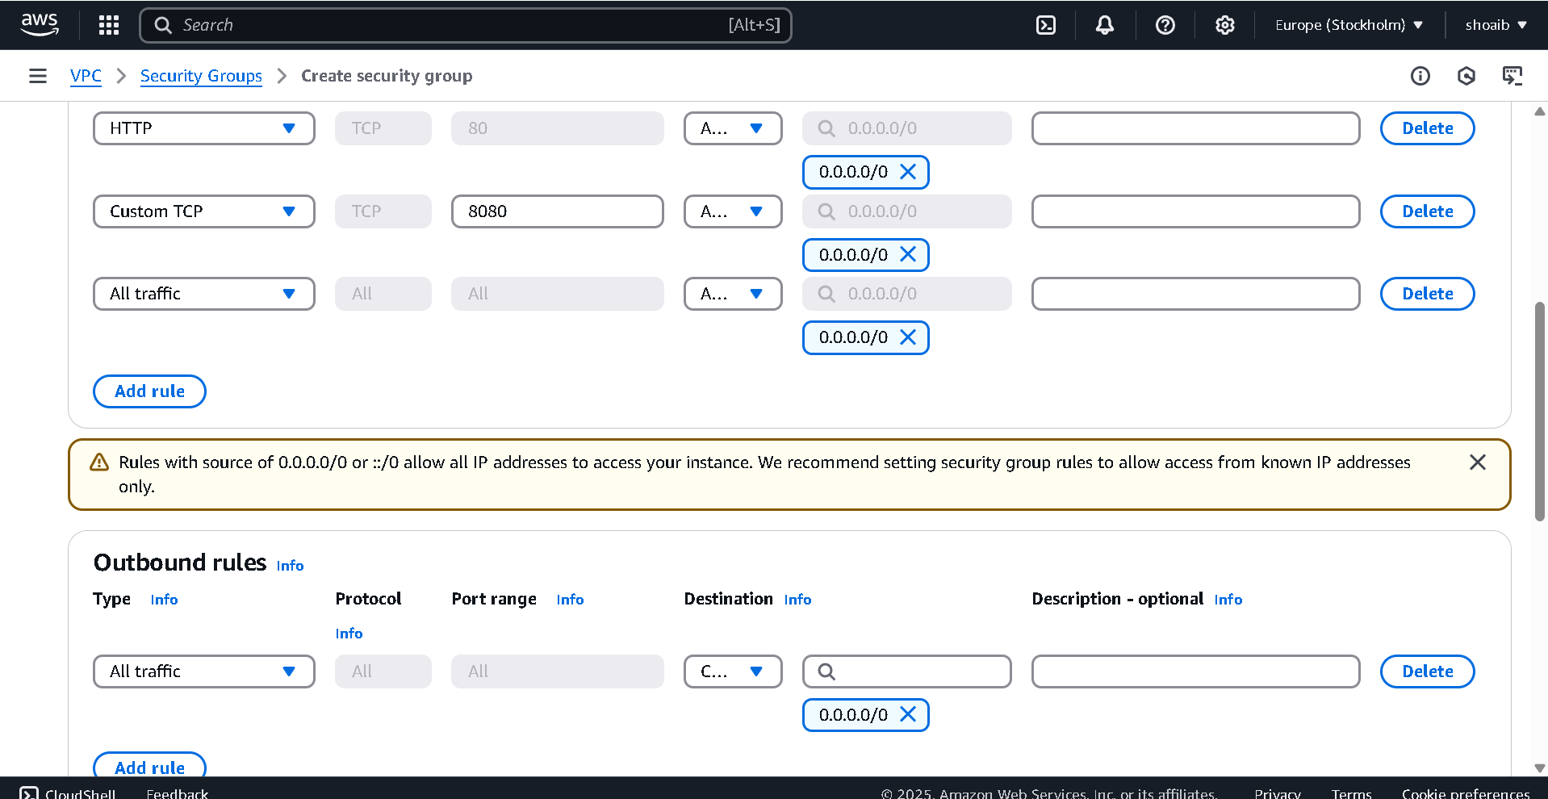

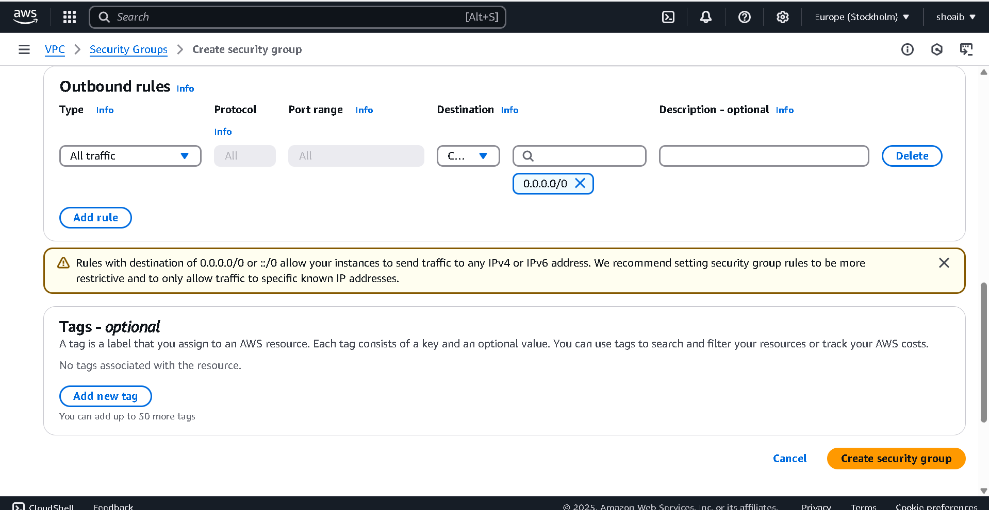

Now go to EC2 and go to Load Balancer
Create Load Balancer and Click Application Load Balancer

Keep Name Nginx-LB
Select your VPC
Select both Availability Zones and subnets
Select your Security groups
Now create target group

Create Target Group
Select IP addresses
Keep name of target group name as nginx1
Create Target Group by using click button

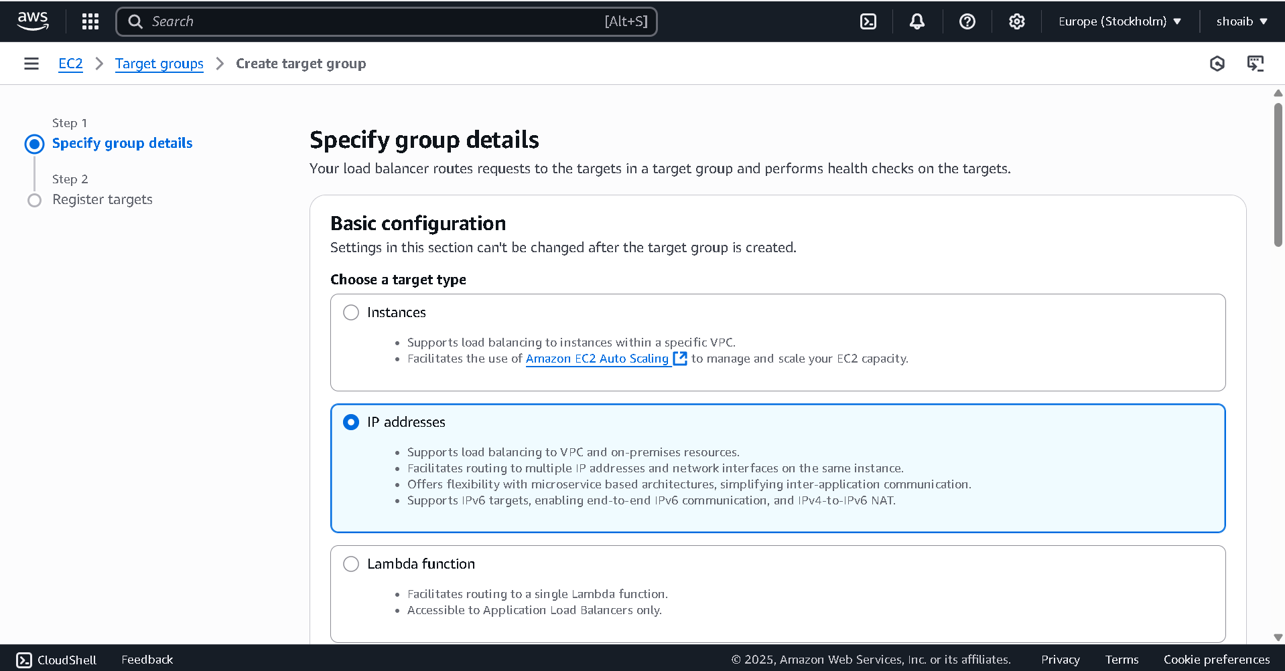
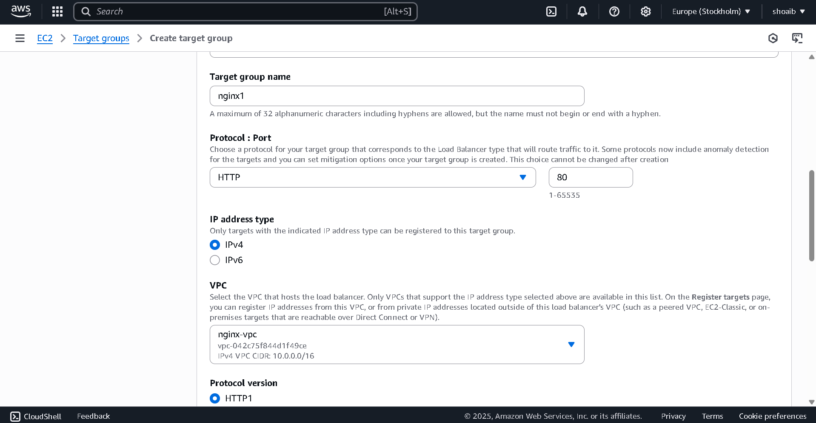

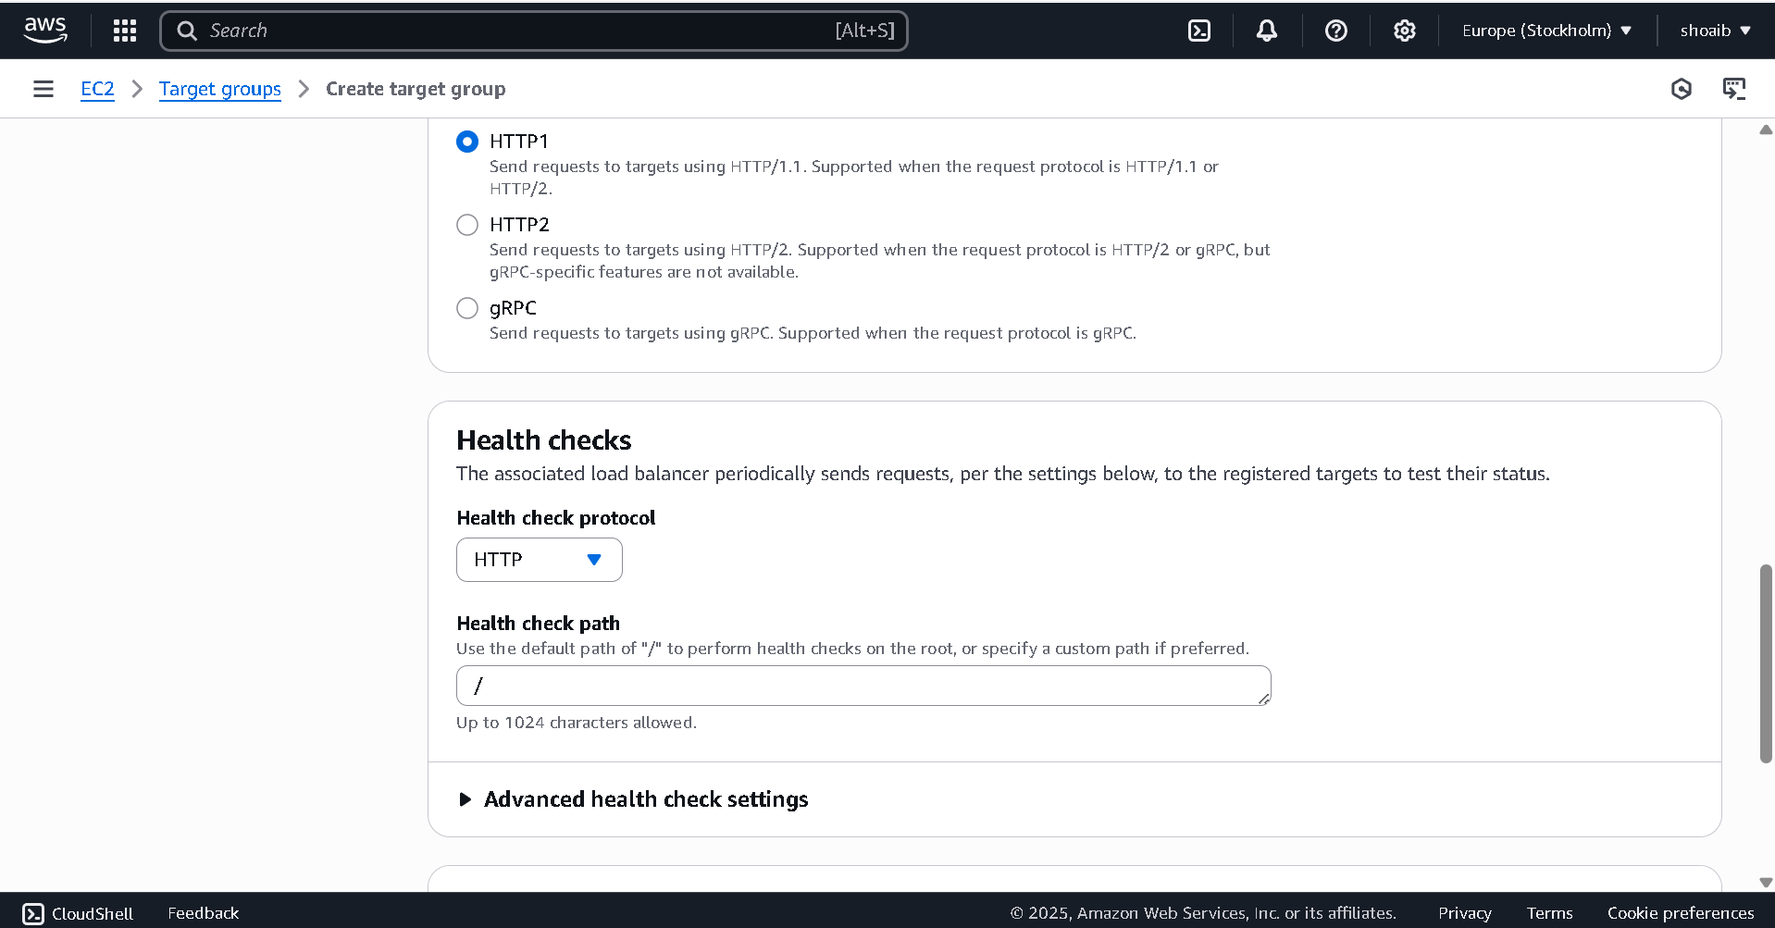

Create second target group
Select IP addresses
Keep name of target group name as nginx2
Keep 8080 port
Select your vpc
Create Target Group by using click button

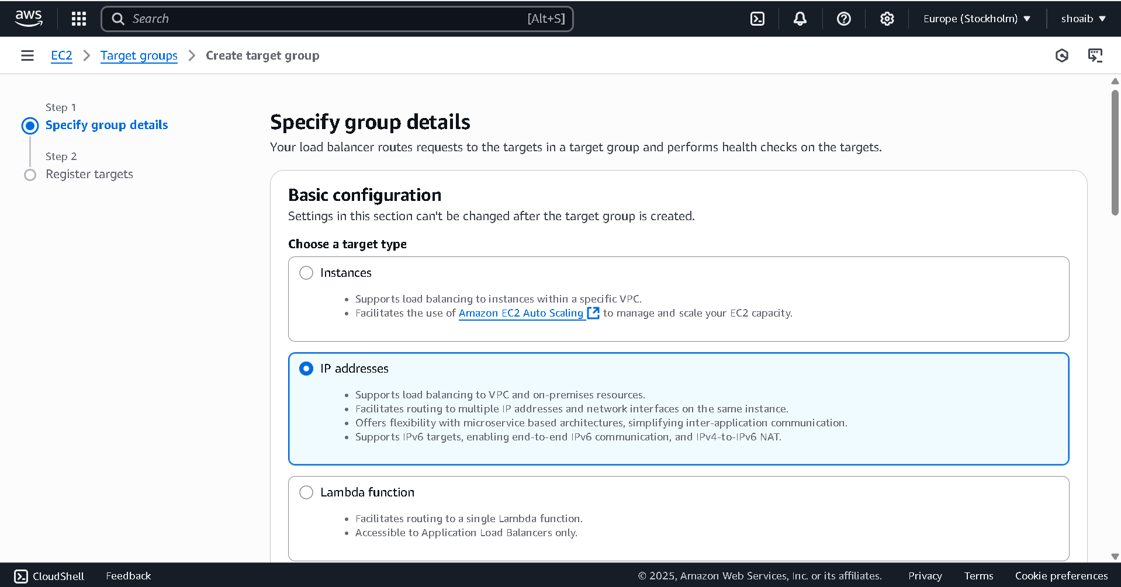

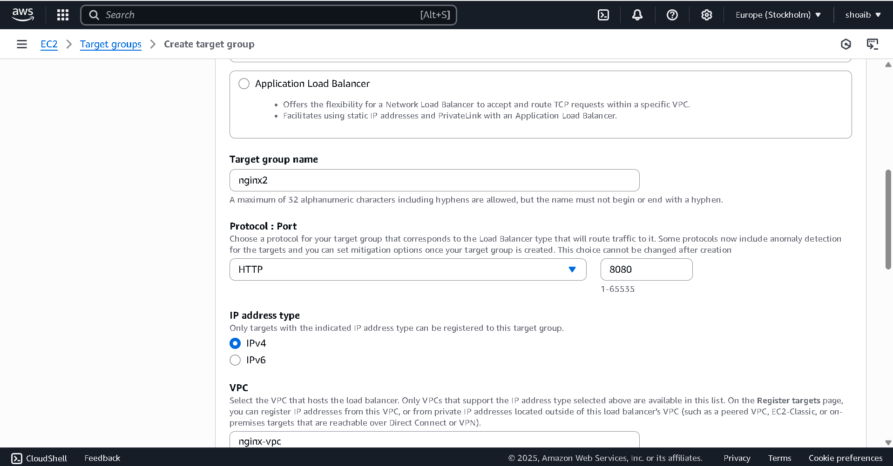

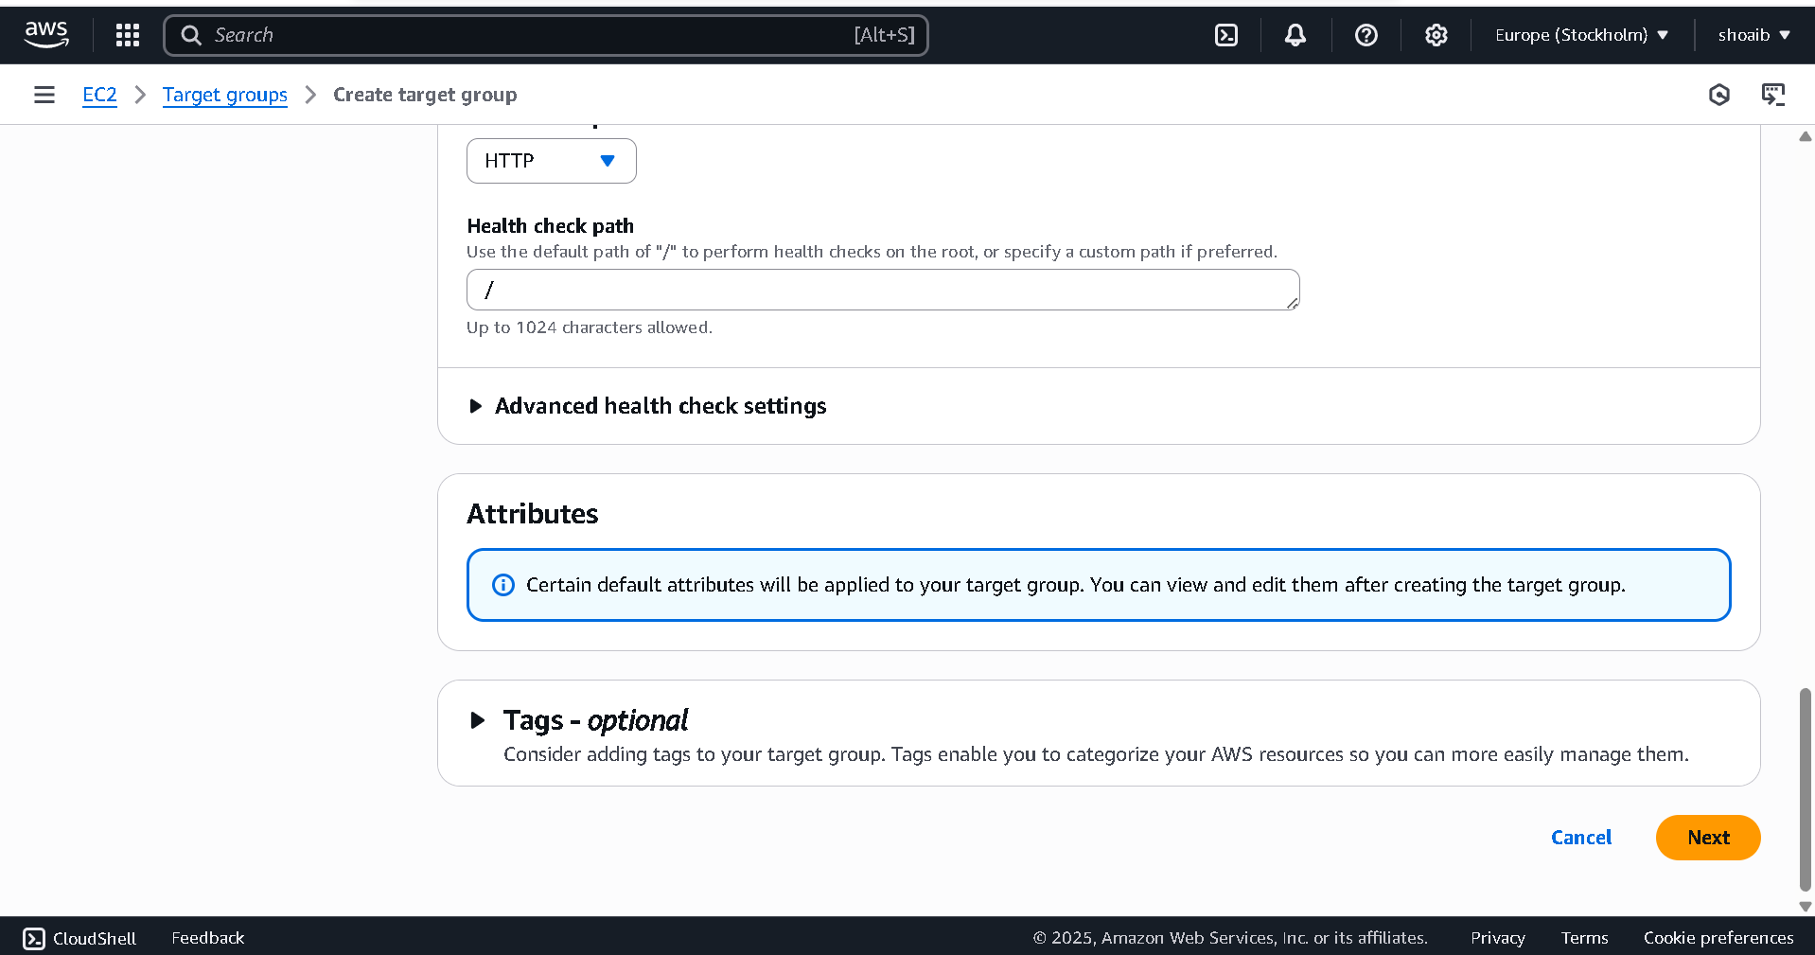

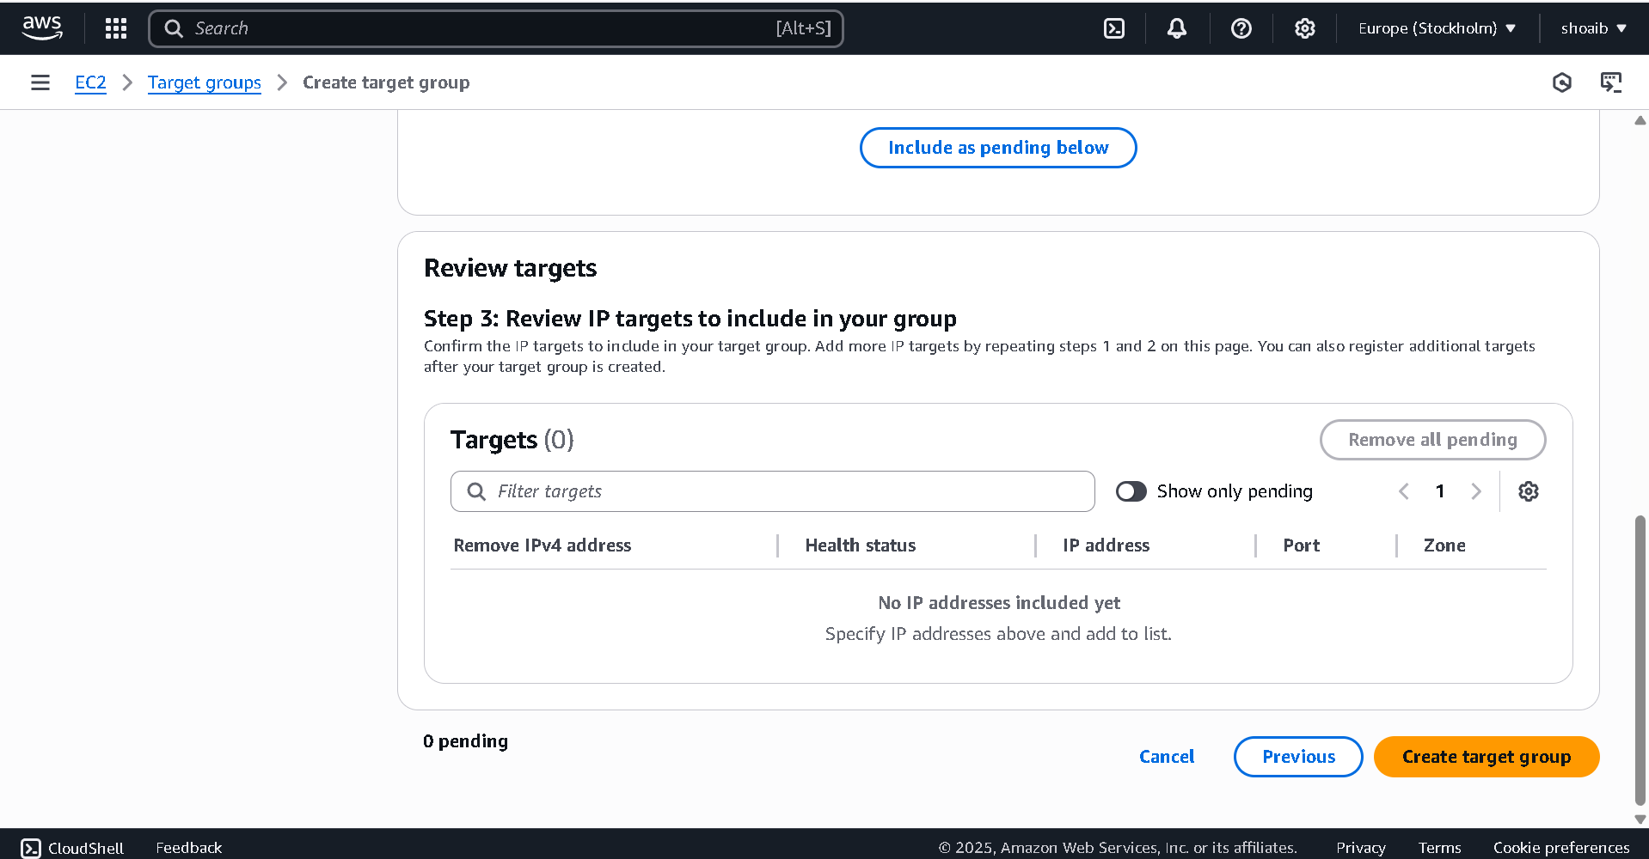

After completed target groups then

Now select nginx1 security group
Create Load Balancer

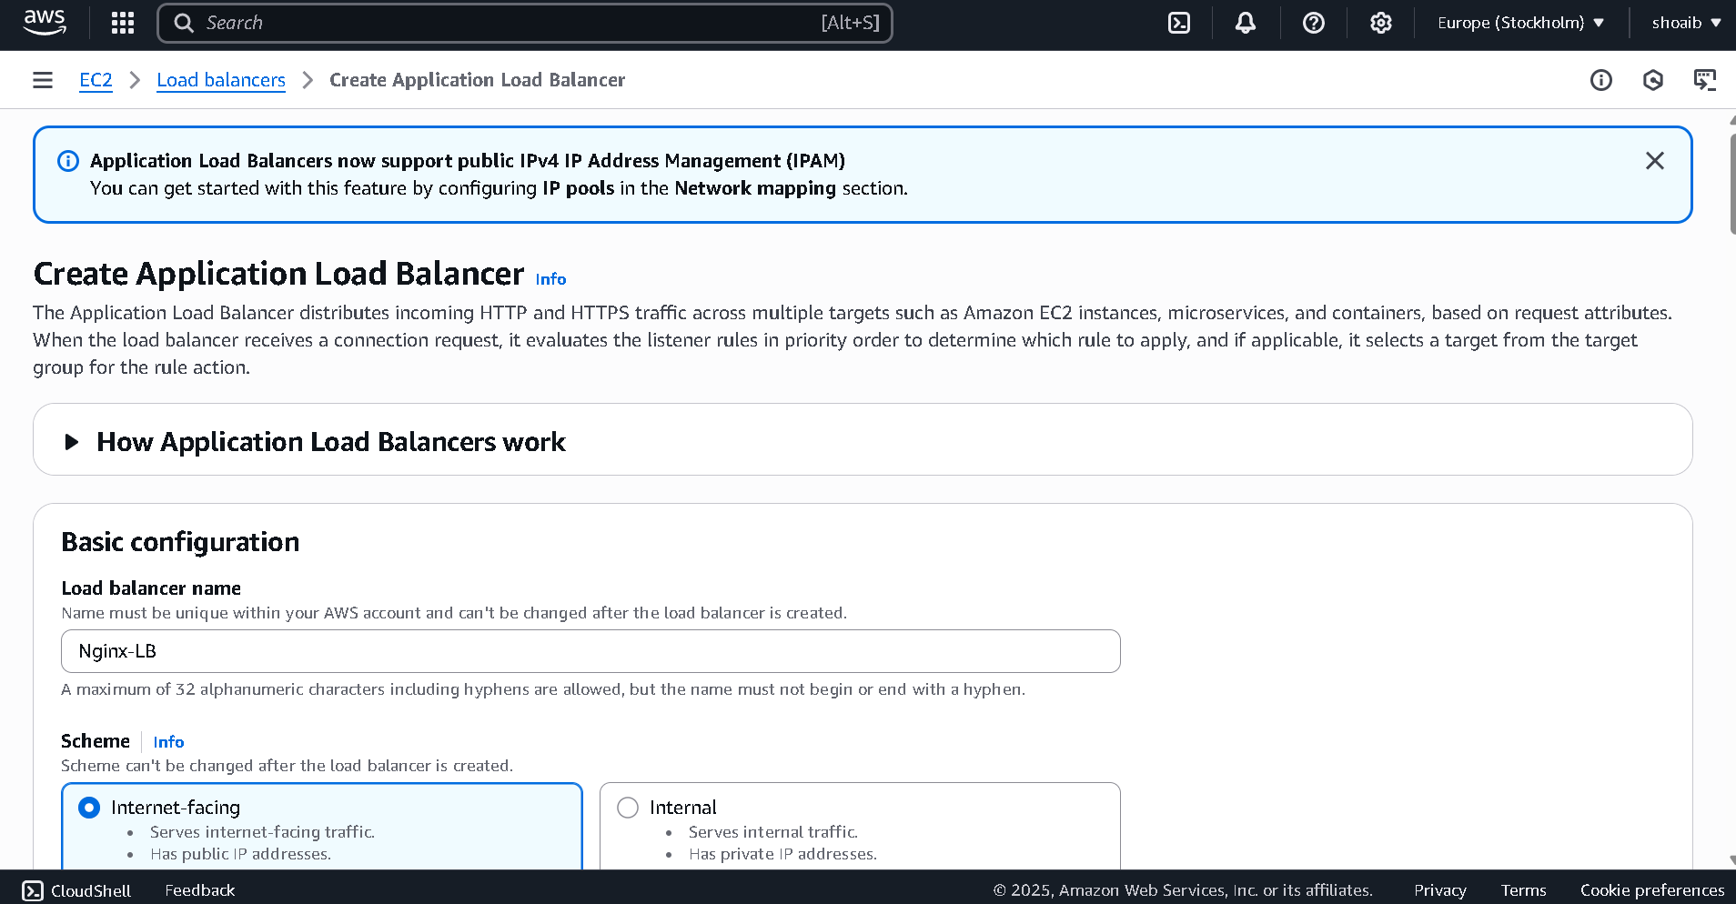

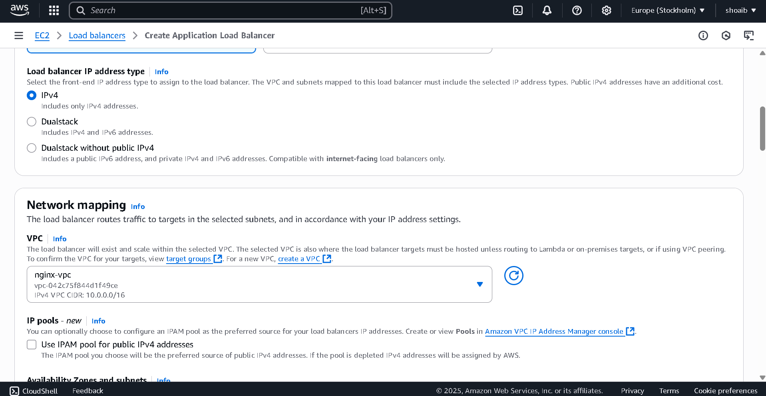

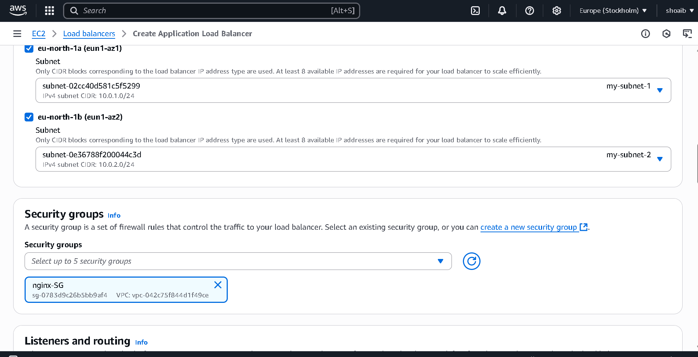

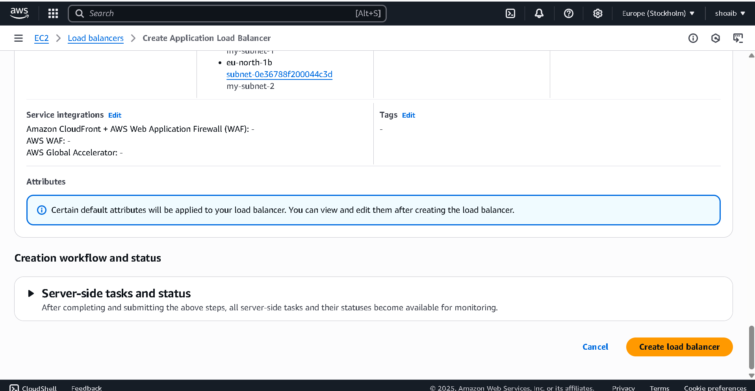

Now go to ECS

Select Cluster and keep name as nginx-cluster
Select AWS Fragat

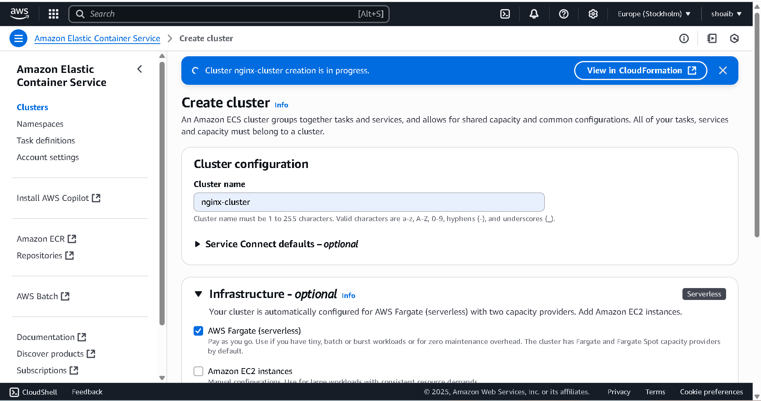
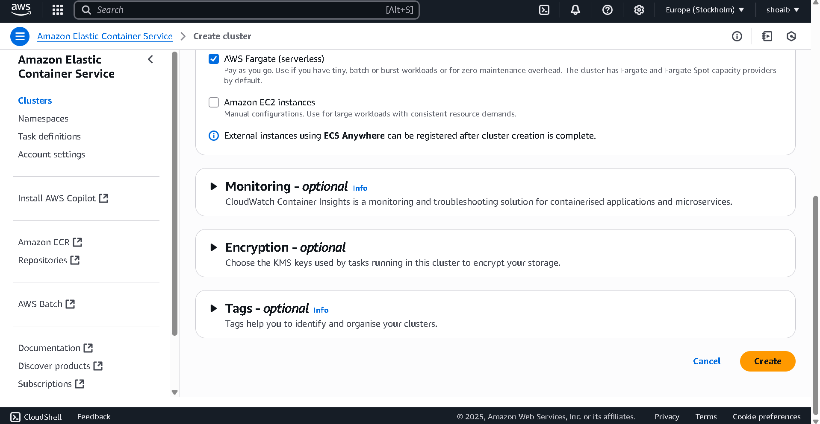

Now go to Task Defination and create Task Definition

Write name like nginx-task
Give name of container and write image url
Write port name also
Then click create button

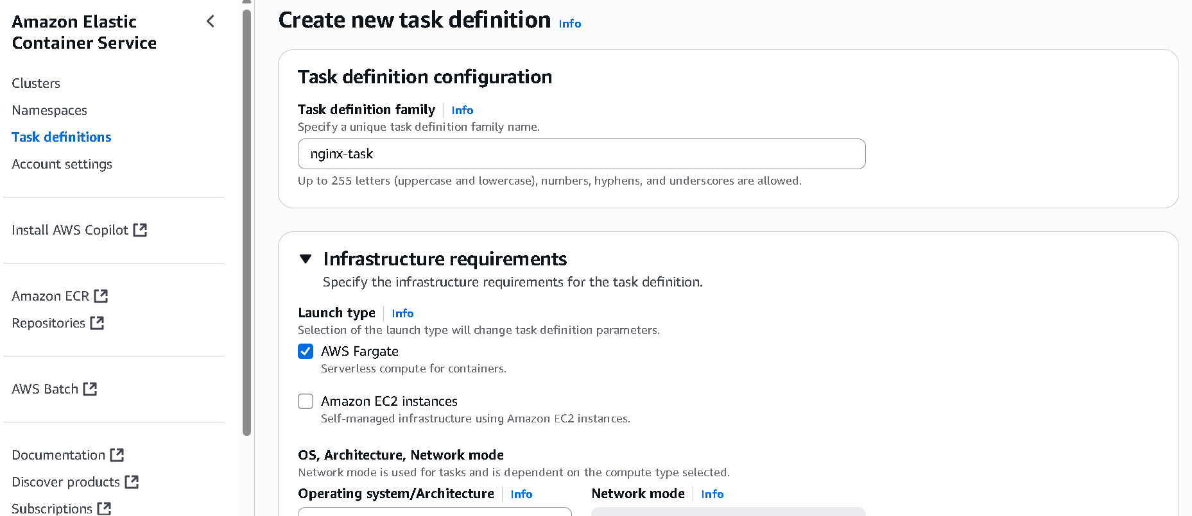

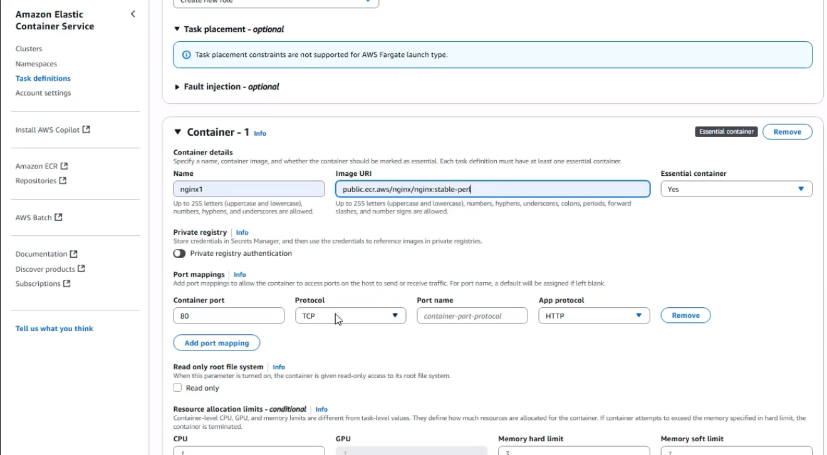

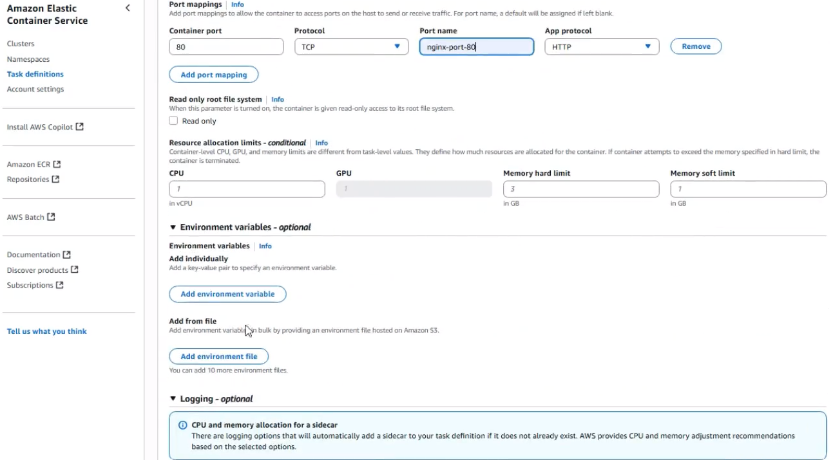

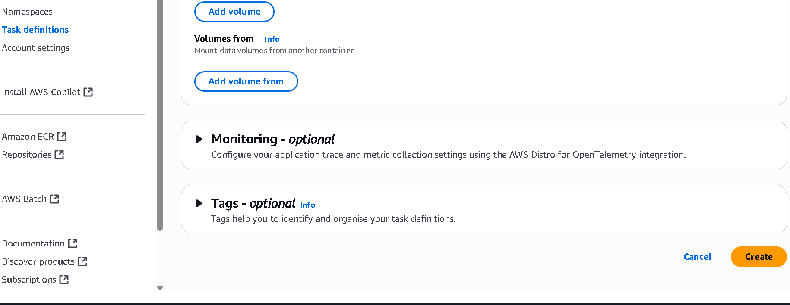

Now go to cluster and create service

Write Task Definition Family Name like nginx-task
Keep service name like nginx-service
Select Launch Type under Compute Options
Select your VPC under Networking
Select your own security group
Keep your own load balancer
Now create service by using clicking button

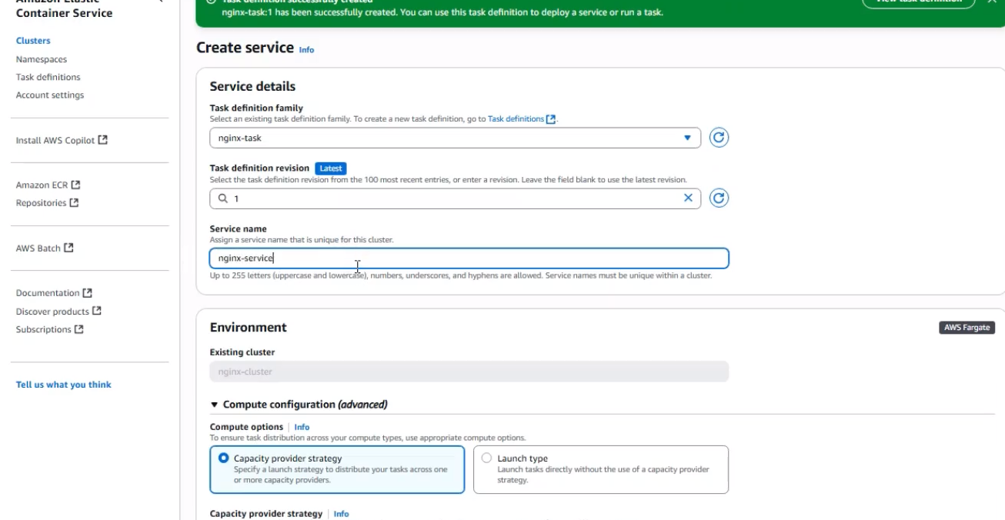

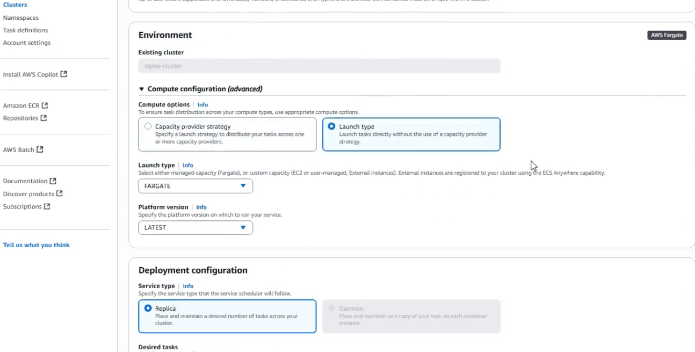

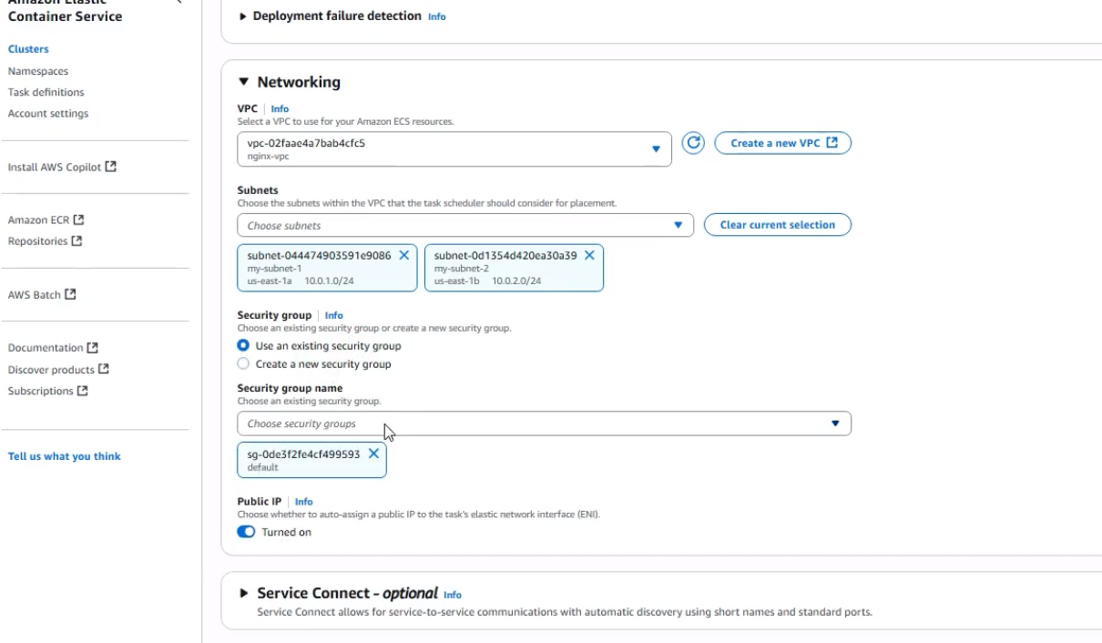

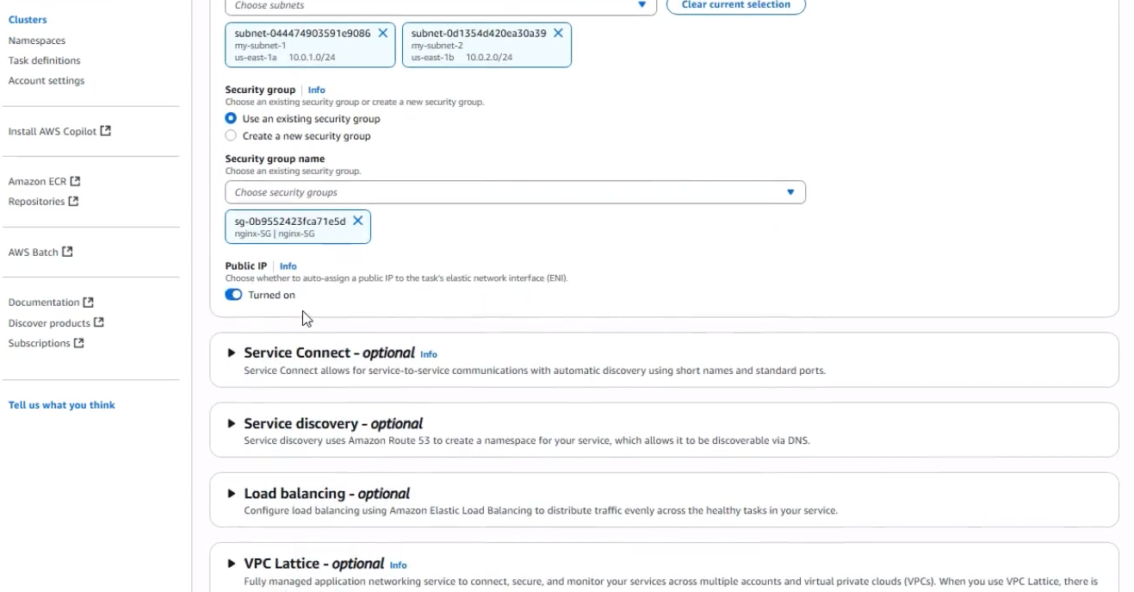
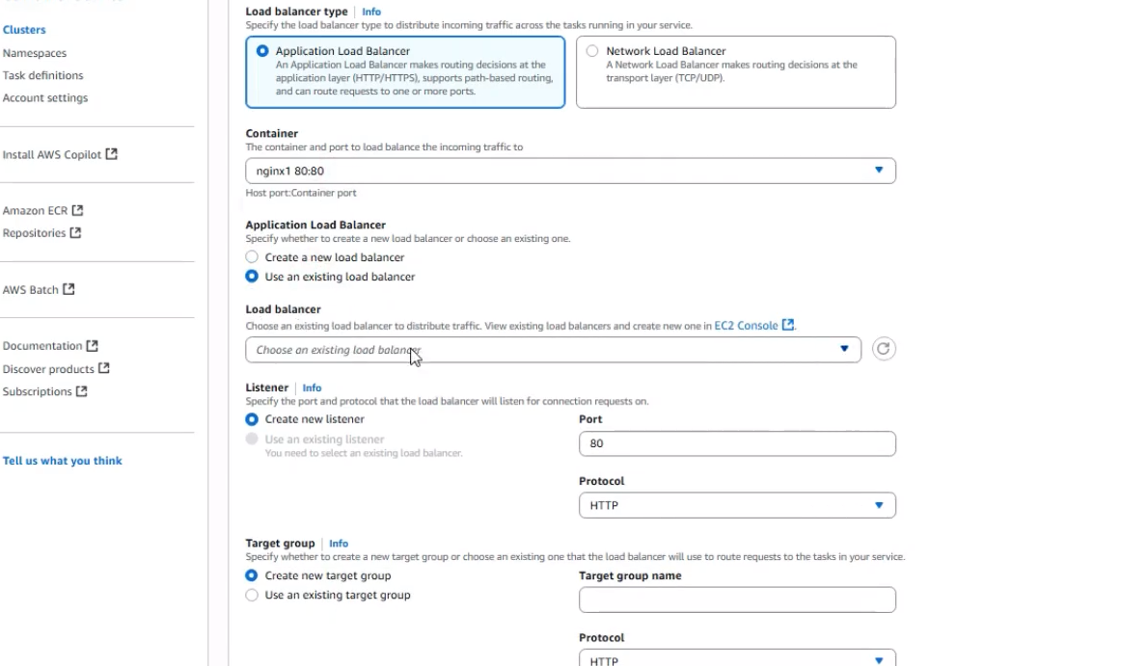

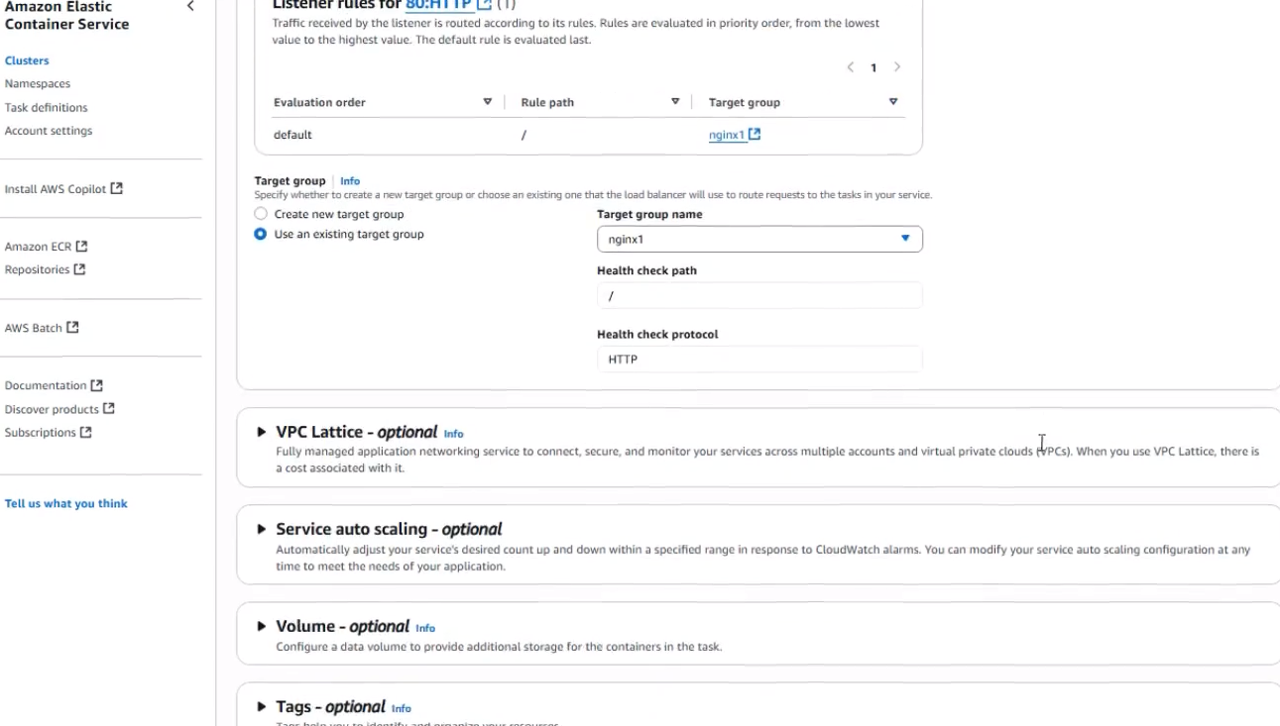

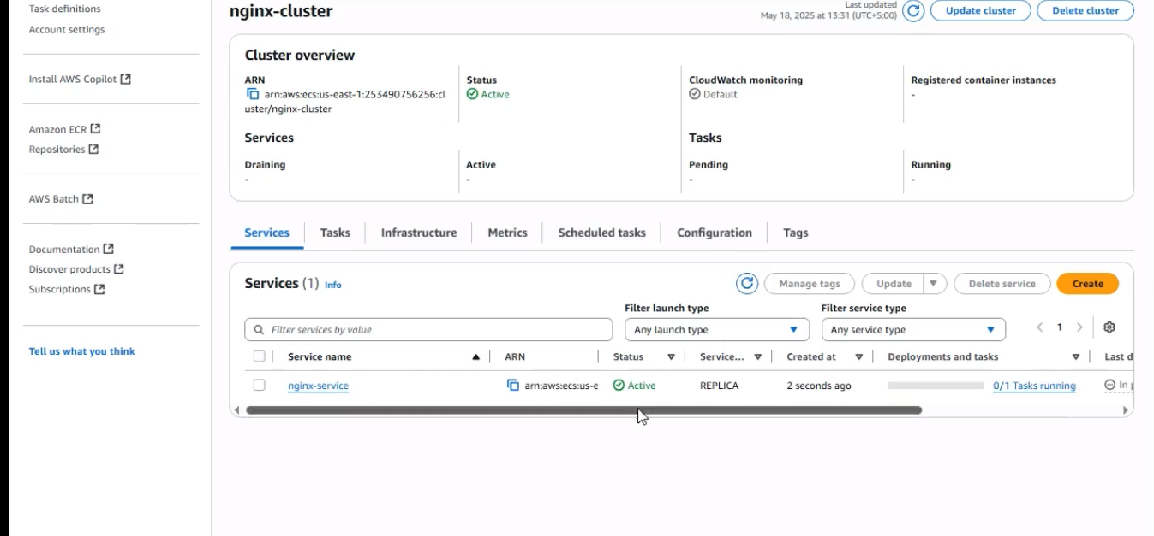

Now go to load balancer and copy name and paste into url

First Output:
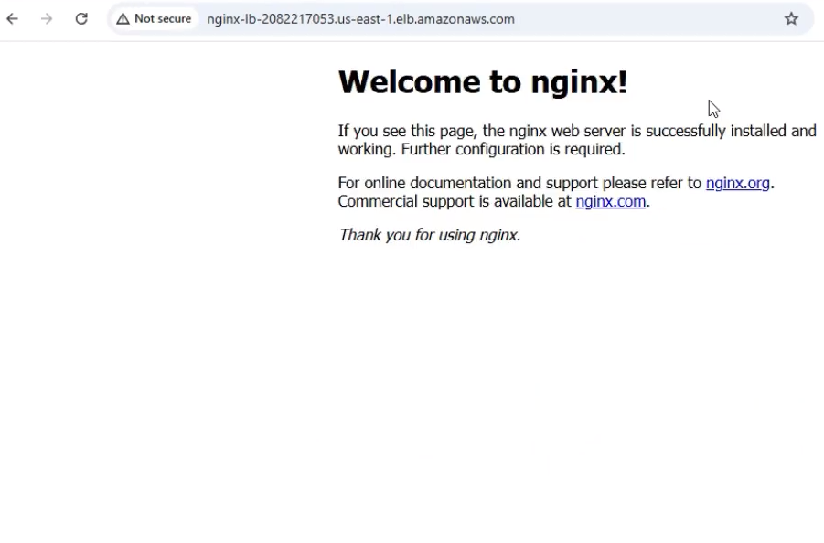

Now add container 2 under Task definition and create new task definition

Select container 2 and keep name like nginx2 and keep image url
Add port mapping and keep 8080 port and keep port name and select http in add protocol
Now create new task definition by clicking button

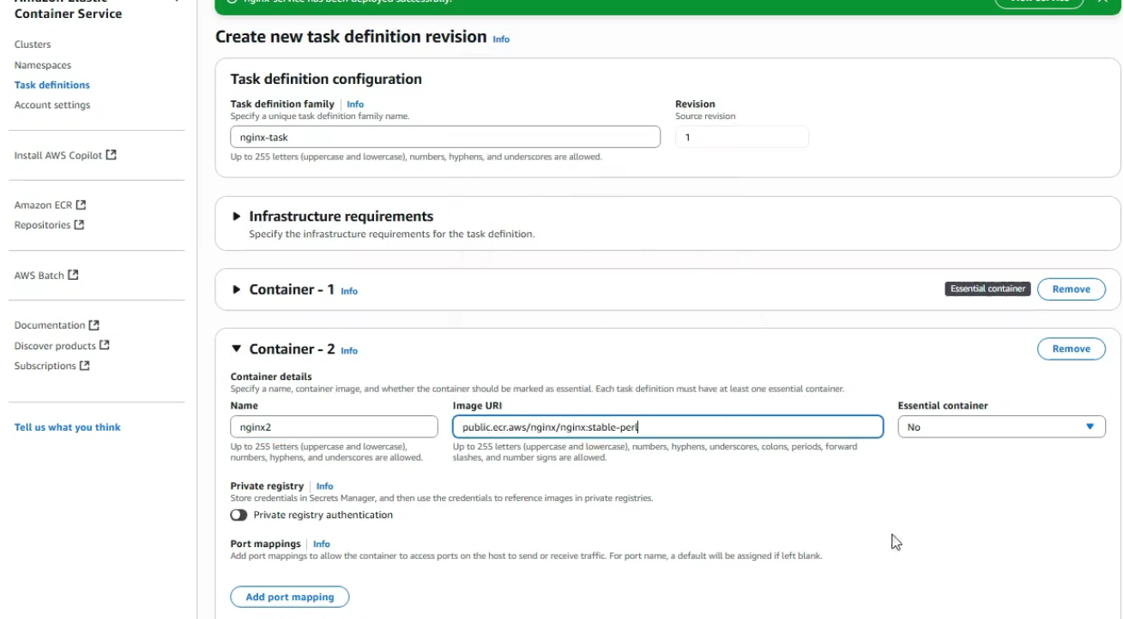
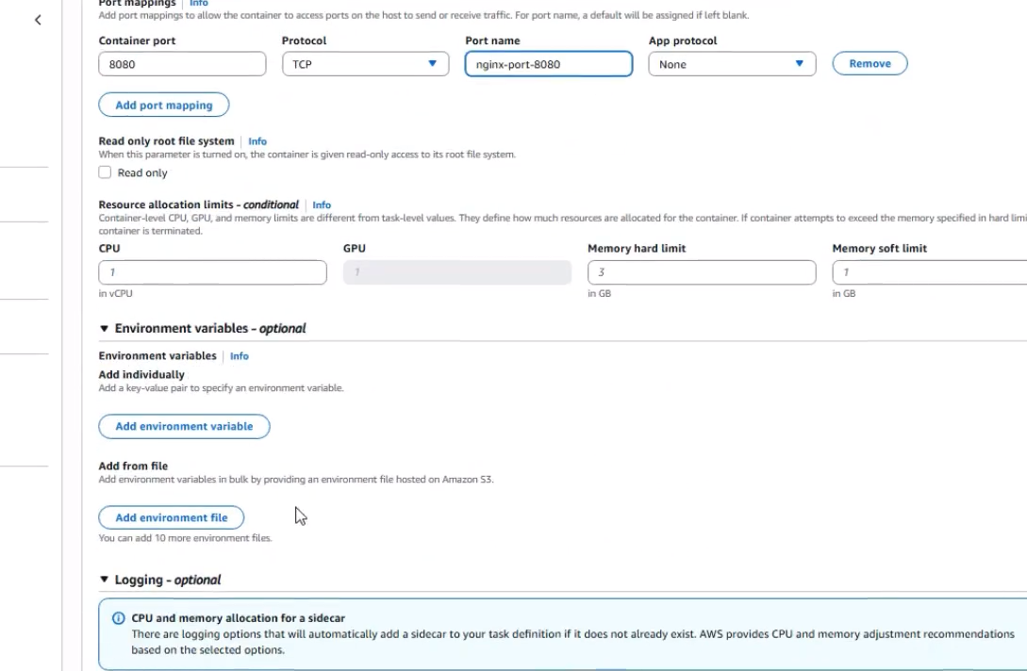

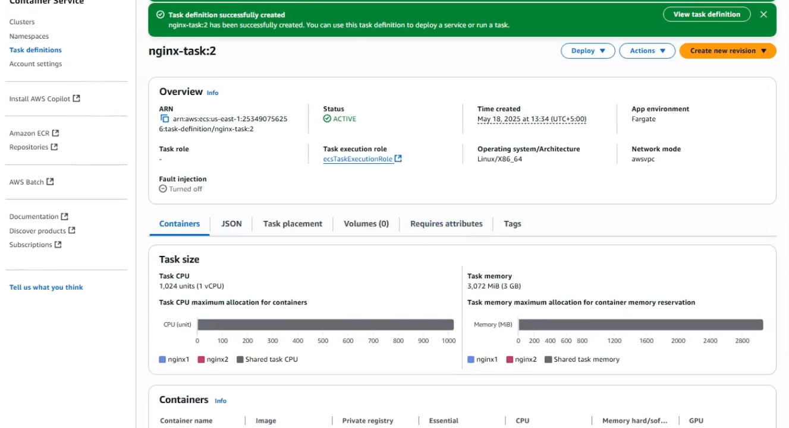
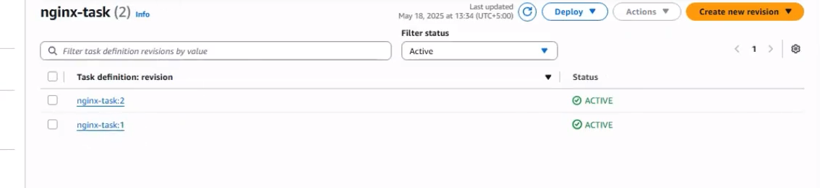

Now update service by changing task definition 2 and then create

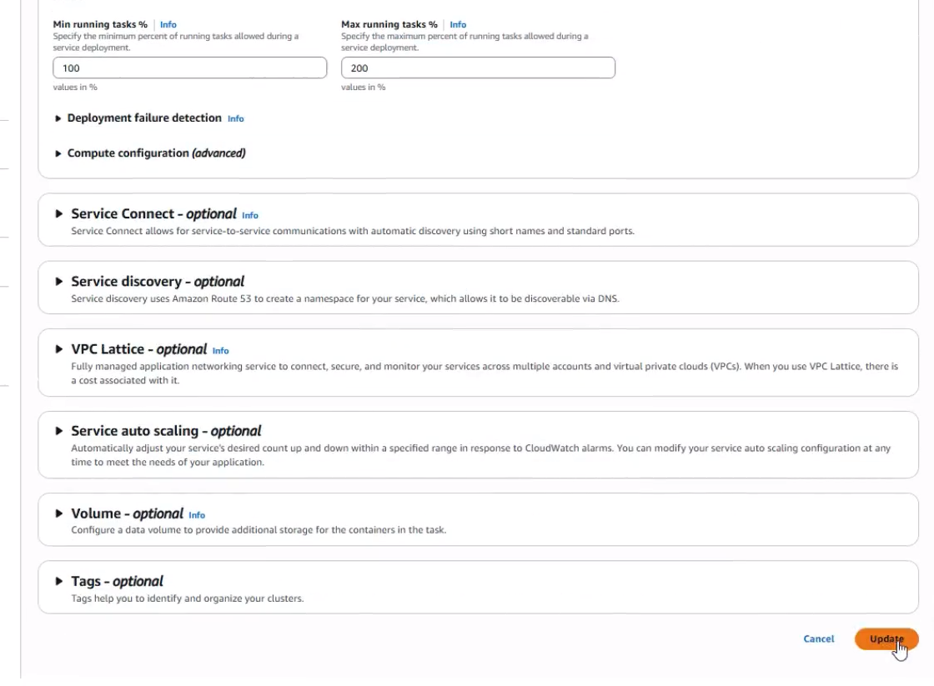

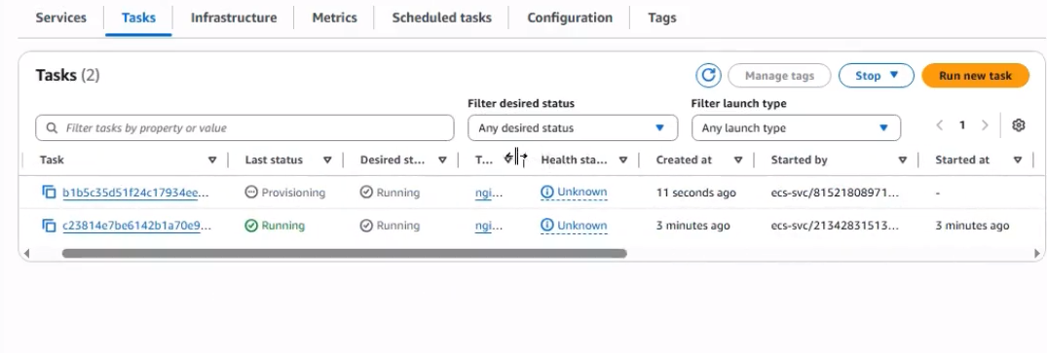

Now go to load balancer
Add listener
Change port 8080
Select nginx2 under Target group
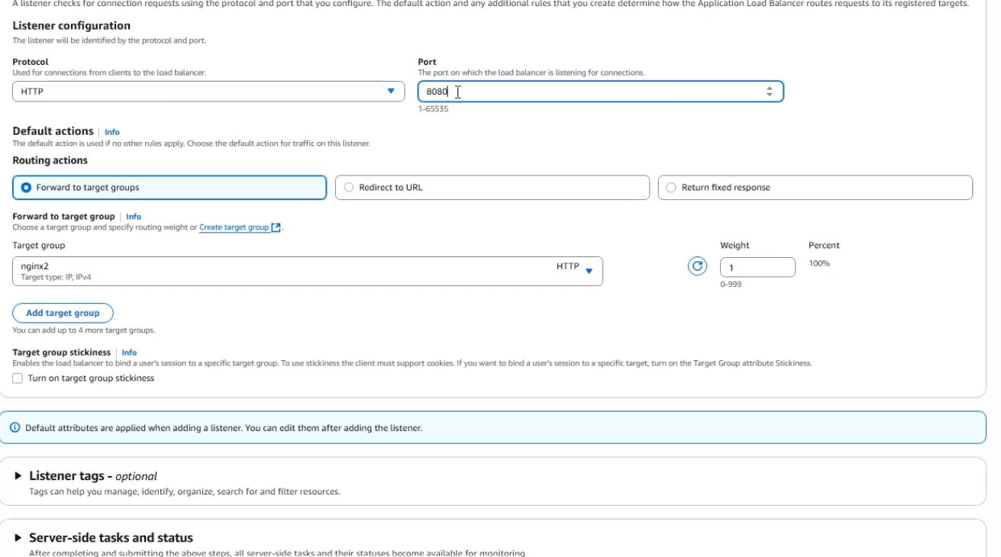

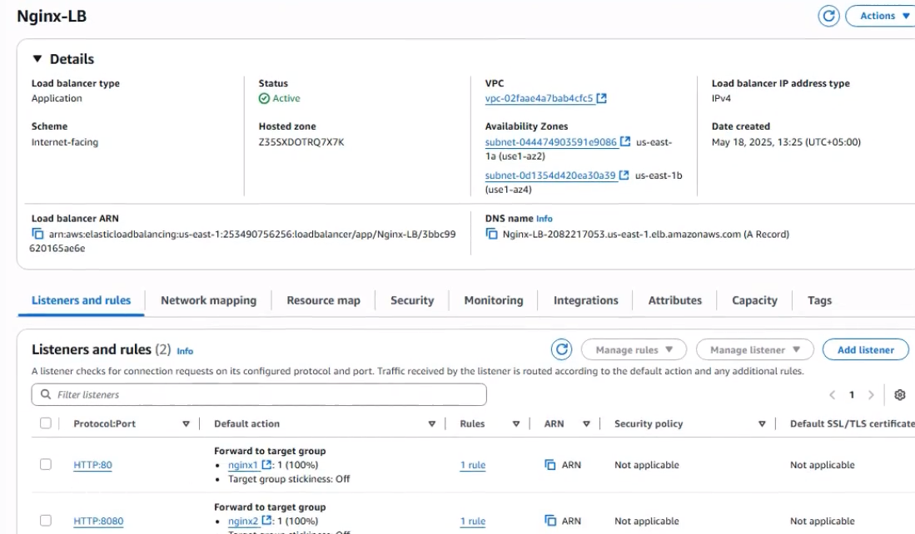

After Editing , you can see the second is deprovisioning
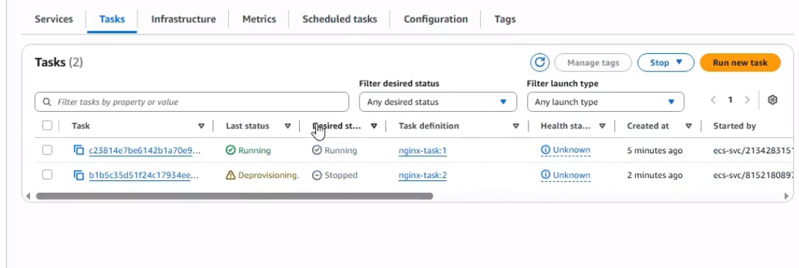

Now go to load balancer and add listener
Select nginx 2
Add port 8080
Then click add button

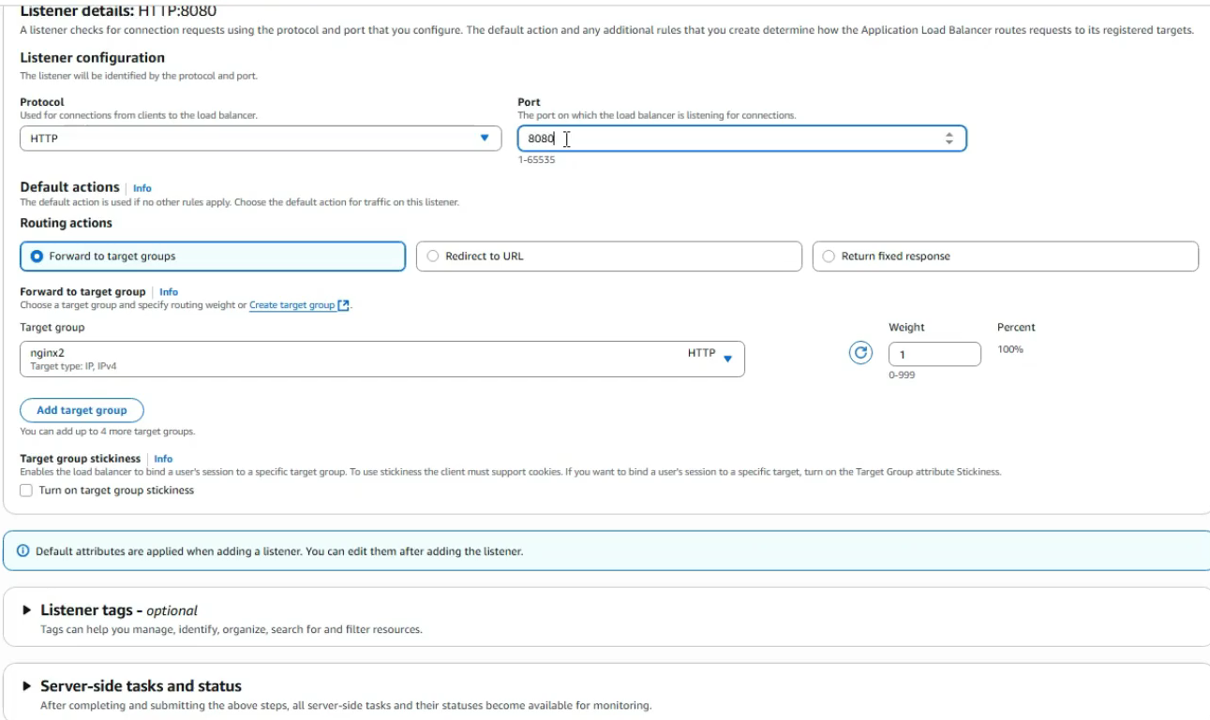

Now we have 2 listeners

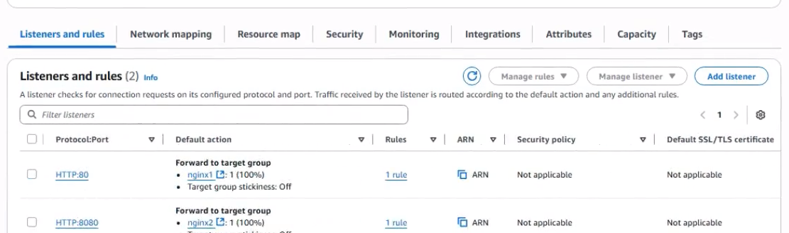

After editing , we have

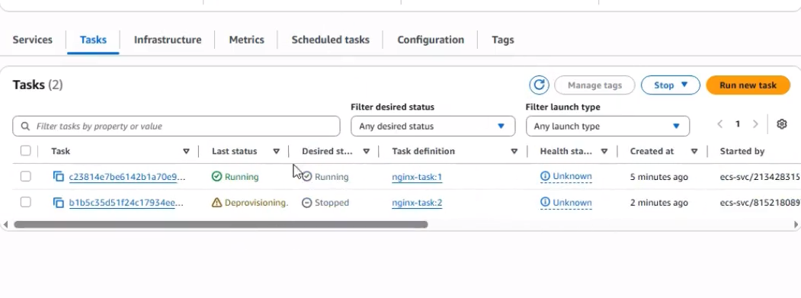
Now go to cluster and update cluster
Click update service
Select 2 in task definition
And click button

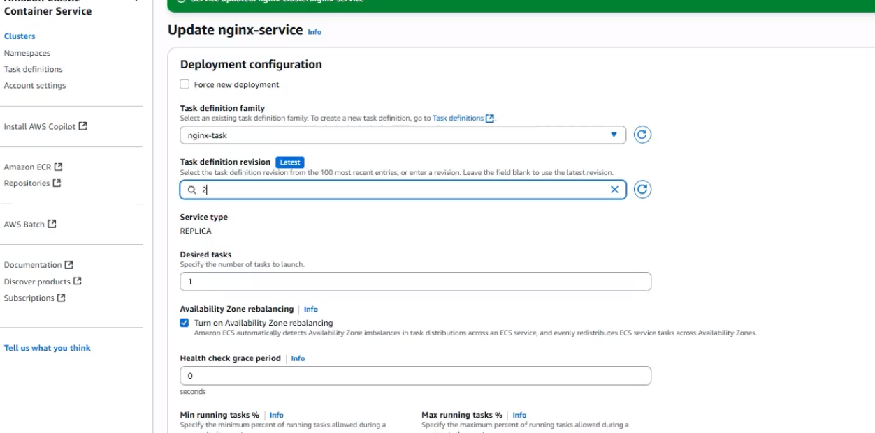

You can see Resouce Map also

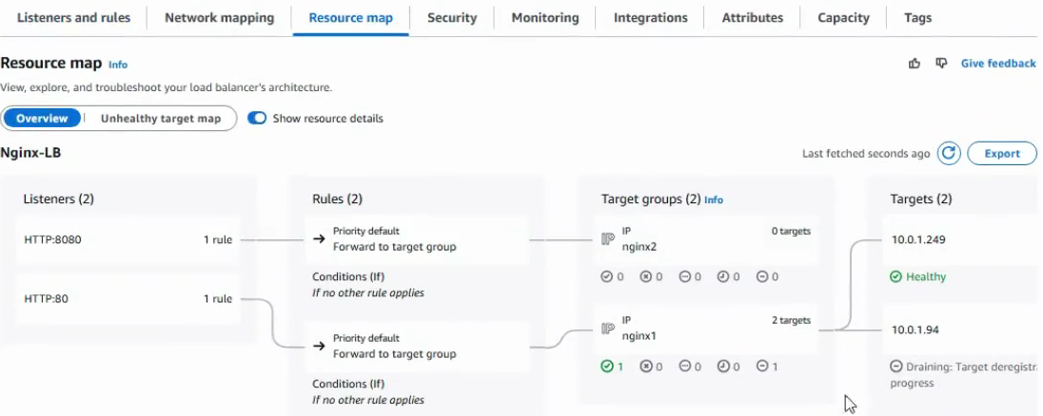

Second Output in port 8080:

